

**Bethel Congregation**

**Midlands Mission Center**

**Welcoming the online community**

Kansas City, KS

May 22, 2022 10:30AM CDT

**Prepare a Sanctuary**

**Presiding Seventy Kyle Joyce**

**Announcements**

**Gathering Hymn** “As the Wind Song through the Trees” **CCS #42**

**Welcome**

**Call to Worship Psalm 67**, adapted

Leader: May God be gracious to us and bless us that God’s way may be known among all nations.

**People:** **We praise you, O God!**

Leader: Let the nations be glad and sing for joy, for you judge the peoples with equity and guide the nations.

**People:** **We praise you, O God!**

Leader: May God continue to bless us. Let all the earth honor the Lord.

**People:** **We praise you, O God!**

**\*Hymn** “Come, Thou Fount of Every Blessing” **CCS #87**

**\*Invocation**

**Prayer for Peace/Community** (CCS #282) **Joseph Rainey**

God is still speaking when children beg for bread, roaming through city streets, their innocence long dead. How can we close our eyes, complacent in our greed?

*God, move our hearts of stone to serve a world in need.*

God is still speaking when exiles cry in pain, forced from their homelands or enslaved for others’ gain. How can we leave them to endure the wounds of hate?

*God, use our broken hearts, a new world to create.*

God is still speaking when people pray for peace, seeing, through eyes of faith, the day when war will cease. How can we cling to hate as God’s name we confess?

*God, let our hearts be changed by love, the world to bless.*

**Scripture Reading Revelation 21:10, 22:1-5**

*And in the spirit he carried me away to a great, high mountain and showed me the holy city Jerusalem coming down out of heaven from God. I saw no temple in the city, for its temple is the Lord God the Almighty and the Lamb. And the city has no need of sun or moon to shine on it, for the glory of God is its light, and its lamp is the Lamb. The nations will walk by its light, and the kings of the earth will bring their glory into it. Its gates will never be shut by day—and there will be no night there. People will bring into it the glory and the honor of the nations. But nothing unclean will enter it, nor anyone who practices abomination or falsehood, but only those who are written in the Lamb’s book of life. Then the angel showed me the river of the water of life, bright as crystal, flowing from the throne of God and of the Lamb through the middle of the street of the city. On either side of the river is the tree of life with its twelve kinds of fruit, producing its fruit each month; and the leaves of the tree are for the healing of the nations. Nothing accursed will be found there any more. But the throne of God and of the Lamb will be in it, and his servants will worship him; they will see his face, and his name will be on their foreheads. And there will be no more night; they need no light of lamp or sun, for the Lord God will be their light, and they will reign forever and ever.*

**Hymn** “I Heard the Voice of Jesus’ Say” **CCS #31**

**Morning Message Elder Grace Troeh**

**Hymn** “For Everyone Born” **CCS #285**

**Disciples Generous Response Doctrine & Covenants 161:6a-b**

*Stand firm in the name of the One you proclaim and create diverse communities of disciples and seekers, rejoicing in the continuing fulfillment of the call to this people to prophetically witness in the name of Jesus Christ. Heed the urgent call to become a global family united in the name of the Christ, committed in love to one another, seeking the kingdom for which you yearn and to which you have always been summoned. That kingdom shall be a peaceable one and it shall be known as Zion*

During the Disciples’ Generous Response, we focus on aligning our heart with God’s heart. Our offerings are more than meeting budgets or funding mission. Through our offerings we are able to tangibly express our gratitude to God who is the giver of all.

As we share our mission tithes either by placing money in the plates or through eTithing, use this time to thank God for the many gifts received in life. Our hearts grow aligned with God’s when we gratefully receive and faithfully respond by living Christ’s mission.

[**https://app.securegive.com/cofchrist/bethel-ks-/donate/category**](https://app.securegive.com/cofchrist/bethel-ks-/donate/category)

**\*Closing Hymn** “With a Steadfast Faith”  **CCS #649**

**\*Sending Forth Alma 10:28 & Psalm 67:1,3** adapted

*Be led by the Holy Spirit in becoming humble, patient, full of love, having faith in the Lord, so that the Lord will be gracious and bless you, that your life be filled with praise and service anchored in God’s peace.*

Bethel Community of Christ  [bethel.forthrightsystems.com](http://bethel.forthrightsystems.com/)

Pastor: Kristine Shipley

Financial Officer: Jeff Cady

Media Host: David Troeh

**CCS**: *Community of Christ Sings*, ©2013, Herald Publishing House

**NRSV**: ©2010, Oxford University Press, Inc. Used by permission. All rights reserved.

Permission to podcast/stream the music and text in this service obtained from One License with license A-727171.

**Announcements**

* Our website, including weekly bulletin and Zoom links [bethel.forthrightsystems.com/](http://bethel.forthrightsystems.com/)
* **Sunday, 5/22 10:30am Prepare a Sanctuary**

Speaking: Elder Grace Troeh

* **Sunday, 5/29 10:30am Receive Blessing**

Speaking: Evangelist Mikal Shedd

* **Center of Hope** needs support on all items, same list as in past
* Give through [eTithing](https://www.cofchrist.org/give) (<https://www.cofchrist.org/give>)

Optionally, search for Bethel, KS ([link](https://app.securegive.com/cofchrist/bethel-ks-/donate/category))

* Video about using [eTithing](https://youtu.be/vOaogMcekbw) (<https://youtu.be/vOaogMcekbw>)

**Lectionary:** 3-year cycle engaging significant portions of our scripture

This w**eek,** May 22, 2022 [**Prepare a Sanctuary**](https://www.heraldhouse.org/products/may-2022-worship-planning)

**John 14:23-29** Acts 16:9-15  
Psalm 67 Revelation 21:10, 22—22:5  
Alma 10:27-28 Doctrine and Covenants 161:6a-b

Next week, May 29, 2022 [**Receive Blessing**](https://www.heraldhouse.org/products/may-2022-worship-planning)

**Luke 24:44-53** Acts 1:1-11  
Psalm 47 Ephesians 1:15-23  
Doctrine and Covenants 158:11 a-b



*Norton Heights Congregation Seeking Congregational Leaders*

One or more experienced, ordained ministers are needed to join the pastor team. Interested individuals should be comfortable with inner city culture and social justice challenges, be passionate about ministry with all ages, and share Norton Heights’s commitment to inclusivity. Contact Janet Dellinger: 816.868.8237 or [jdellinger1@gmail.com](mailto:jdellinger1@gmail.com)

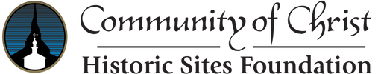

*Historic Sites Volunteers & Summer Interns*

**SAVE THE DATE**

Temple Planting May 1

**Chihowa Work Day 9am Saturday, May 14**

CACH Postal Drive May 14

Refugee Info Mtg May 17

Worldwide Worship June 12

Come share the history of Community of Christ with visitors from all over the world! The Kirtland Temple (Kirtland, OH) and the Joseph Smith Historic Site (Nauvoo, IL) are looking for summer 2022 history interns. In addition to interpreting the past, interns assist in museum store sales, help host congregational retreats, special events, and evening hymn festivals. Furnished housing and utilities are provided, and **summer interns receive a stipend and college credit**.

Midlands & Farwest Mission Centers Senior High Youth (finishing 9-12 grades) are invited on a bus trip June 2–12 to Community of Christ historic sites and other cities to explore our past and how it affects our future. Donations can be made with check or eTithing to the MMC Youth Fund.

To prepare for the trip, we are hosting six zoom sessions with guest speakers to connect with each other and learn CofChrist history.

**8 – 10 pm Wednesdays through May 18**

**HISTORIC CARAVAN**

For more information, contact Sally Roth 316.393.3037 or visit:

* Nauvoo internship: [cofchrist.org/history-intern-nauvoo-illinois/](https://cofchrist.org/history-intern-nauvoo-illinois/)
* 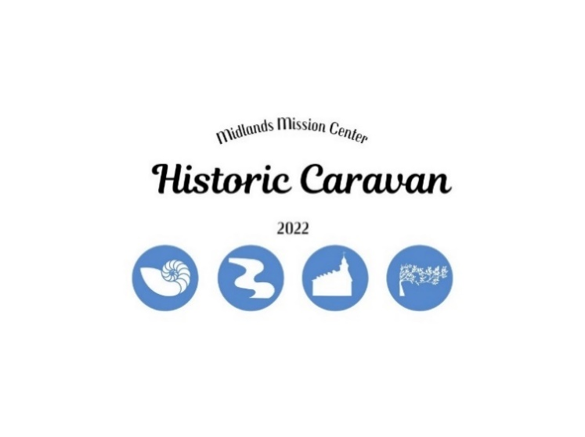Nauvoo volunteer:[*explorenauvoo.com/volunteer*](https://nam04.safelinks.protection.outlook.com/?url=https%3A%2F%2Fexplorenauvoo.com%2Fvolunteer&data=05%7C01%7Ckhnatyshyn%40cofchrist.org%7C3270eaacc6a6422d44a408da27c39a08%7C8afd0cc8f92c4ae0a7e2e6d4b8382b4e%7C0%7C0%7C637866018307638961%7CUnknown%7CTWFpbGZsb3d8eyJWIjoiMC4wLjAwMDAiLCJQIjoiV2luMzIiLCJBTiI6Ik1haWwiLCJXVCI6Mn0%3D%7C3000%7C%7C%7C&sdata=dwFtLQkXuwUK3ouGKPHXE2xH%2FY4ybWfr8bZUWofnD%2BQ%3D&reserved=0)
* Kirtland internship: [*cofchrist.org/history-intern-kirtland-ohio*](https://nam04.safelinks.protection.outlook.com/?url=https%3A%2F%2Fcofchrist.org%2Fhistory-intern-kirtland-ohio&data=05%7C01%7Ckhnatyshyn%40cofchrist.org%7C3270eaacc6a6422d44a408da27c39a08%7C8afd0cc8f92c4ae0a7e2e6d4b8382b4e%7C0%7C0%7C637866018307638961%7CUnknown%7CTWFpbGZsb3d8eyJWIjoiMC4wLjAwMDAiLCJQIjoiV2luMzIiLCJBTiI6Ik1haWwiLCJXVCI6Mn0%3D%7C3000%7C%7C%7C&sdata=oeaiyLrKP2Pa750rBzZXu6aiLvOfadSkrZJ5iaCSQe0%3D&reserved=0)
* Kirtland volunteer: [*www.kirtlandtemple.org/volunteer*](http://www.kirtlandtemple.org/volunteer)

*Central Avenue Center of Hope Postal Drive*

On May 14th postal carriers will collect non-perishable food items for organizations around Kansas City. Some of these donations will go to CACH. Volunteers are needed to transport the goods from post offices to the center. **Earn $50 in campership funds by participating.** Watch the MMC Facebook page for more information.



7615 Platte Purchase Dr, Suite 116 phone 816-221-4450

Kansas City, MO 64118 www.midlandsmc.org

**WORLD CHURCH UPDATES**

The church is curious about the needs and desires of our younger members and friends. Many people have a connection to the church from childhood or through camps and reunions but may not be active in regular church activities. Please encourage friends and family ages 18 – 50 to share an email or mobile number to participate in a simple survey. <https://bit.ly/18-50survey>

Annual Temple Planting

**6 pm Sunday May 1**

**Harmony continues their** tradition of providing colorful flowers in the planters surrounding the Temple. Bring gloves, work clothes, trowel if available, hats/sunscreen, water/snacks, and comfortable shoes. Email [info@harmony.lgbt](mailto:info@harmony.lgbt) with questions and to RSVP. Donations ensure this important tradition can continue: [www.harmony.lgbt/donate](https://midlandsmc.us11.list-manage.com/track/click?u=fe105f08640259805df7e3fb8&id=b42c0bc2d4&e=bb50cbc5b5).

Refugee Resettlement Information Meeting

**7 pm Tuesday May 17**

The Justice and Peace Action Team of Greater Kansas City, sponsored by Central and Midlands Mission Centers, is hosting this ZOOM event. There are many ways to assist families to become established and contributing members of our communities. Guest speakers will cover how individuals and congregations can engage in refugee resettlement efforts in the KC area.

If you have any questions, please contact Jim Resch (913.568.5118) or Stan Troeh (913.522.9516). **Register at** [bit.ly/JPATrefugeeresettlement](https://bit.ly/JPATrefugeeresettlement)

USA Field Conversations on Non-Violence

**7 pm Thursdays March 28 – May 5**

### **Join diverse voices in discussions of WCR 3119 for World Conference 2023. Register at** [www.midlandsmc.org/ministries](http://www.midlandsmc.org/ministries)**.**

Summer Camp Registration is LIVE!!!

Go to [www.midlandsmc.org](http://www.midlandsmc.org/) and click the blue “Camp Registration” button.

Experience Reunion!!!

Something for everyone! Come join for family fun, fellowship, fishing, swimming, campfires, canteen, classes, boating, good food, study, and wonderful guest ministry.

**Doniphan** – Excelsior Springs, MO – June 29 to July 3

[](https://www.google.com/url?sa=i&rct=j&q=&esrc=s&source=images&cd=&cad=rja&uact=8&ved=2ahUKEwj3xuWJ0_7YAhUC5GMKHagWBdkQjRx6BAgAEAY&url=https://pixabay.com/en/camping-humor-tent-humorous-23792/&psig=AOvVaw1NczEahqtV6Pbew_roVTqH&ust=1517366023418722)Guest Ministers: Jim and Sharon Hannah

Planning Committee meets Monday evenings

**Chihowa** – Perry, KS – July 10 to 15

Guest Ministers: Brian and Sara Tubbesing

Planning Committee meets Sunday evenings

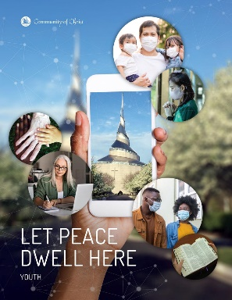

**WE NEED YOUR HELP!** *Please email*

[*khnatyshyn@cofchrist.org*](mailto:khnatyshyn@cofchrist.org) *to join a planning committee or share your*

*ministry.* **Nursery workers must be

Youth Worker certified.

2022 Reunion Prices

Adults (age 18+) $240

Youth (age 13-17) $125

Children (age 5-12) $75

Children (age 0-4) $25

Camperships Are Available

2022 Summer Camping Schedule

June 2 – 12 Senior High Caravan July 10 – 15 Reunion @ Chihowa

June 19 – 23 JR Camp @ Chihowa July 16 – 23 Spectacular @ GU

June 19 – 24 MS Camp @ Chihowa July 28 – 30 Youth Quest @ TBD

June 29 – July 3 Reunion @ Doniphan