

**Bethel Congregation**

**Midlands Mission Center**

**Welcoming the online community**

Kansas City, KS

July 3, 2022 10:30AM CDT

**Forgive Our Sins**

**Presiding High Priest Stan Troeh**

**Announcements**

**Gathering Hymn** “As God Is Joy” **CCS #366**

**Welcome**

**Invitation to Worship 2 Corinthians 13:11-13,** adapted

*Friends, listen! Be cheerful! Be uplifting!*

*Be unified in peace and the God of love and peace will dwell here. Greet one another with God’s holiness. Greet one another with God’s love. Greet one another with God’s peace. The amazing grace of Christ, the extravagant love of God, and the intimate friendship of the Holy Spirit is with us!  
We are all invited…hallelujah! Amen!*

**\*Hymn**  “In Christ We Live” **CCS #326**

**\*Invocation**

**\*Response**

**Prayer for Peace**

Creator God, Creating still,

We seek your shalom,

we are vulnerable to your grace,

we embrace your peace,

all so freely given.

This broken work, God, hurts deeply.

The earth-tears tear at our heart.

You are our only hope in this war-torn,

unjust world. You are our healer and teacher.

Teach us, again, how to bring peace.

At this time of revitalization,

re-enthuse our efforts to

share peace;

make, build, reveal peace;

honor, follow, strengthen peace;

learn and teach peace,

live and embody peace,

to be a sanctuary of Christ’s peace –

within ourselves, in our families, in our

communities and around the world.

Amen.

**Communion Exploration Teacher Kalene West**

**Communion Scripture Mark 14:22-25**

*22 While they were eating, he took a loaf of bread, and after blessing it he broke it, gave it to them, and said, “Take; this is my body.” 23 Then he took a cup, and after giving thanks he gave it to them, and all of them drank from it. 24 He said to them, “This is my blood of the covenant, which is poured out for many. 25 Truly I tell you, I will never again drink of the fruit of the vine until that day when I drink it new in the kingdom of God.”*

**Invitation to Communion**

All are welcome at Christ’s table. The Lord’s Supper, or Communion, is a sacrament in which we remember the life, death, resurrection, and continuing presence of Jesus Christ. In Community of Christ, we also experience Communion as an opportunity to renew our baptismal covenant and to be formed as disciples who live Christ’s mission. Others may have different or added understandings within their faith traditions. We invite all who participate in the Lord’s Supper to do so in the love and peace of Jesus Christ.

**Hymn** “Coming Together for Wine and for Bread” **CCS #516**

**Blessing and Sharing the Bread and the Wine**

**Spiritual Exercises**

**Examen – prayer of St. Ignatius of Loyola (early 1500’s)**

1. **Become aware of God’s presence.**  
2. **Review the day with gratitude.**   
3. **Pay attention to your emotions.**  
4. **Choose one feature of the day and pray from it.**  
5. **Look toward tomorrow.**

**Disciples’ Generous Response**  **D&C 164:4c**

*4c Explore all the ways the Lord’s Supper can spiritually form the church community into a true and living expression of the life, sacrifice, resurrection, and continuing presence of Christ. Inherent in this sacrament is the divine call for the church to be a sacramental offering for the blessing, healing, and peace of creation.*

**\*Hymn** “Community of Joy” **CCS #631**

**\*Benediction**

**\*Response**

*congregation standing as able

Bethel Community of Christ  [bethel.forthrightsystems.com](http://bethel.forthrightsystems.com/)

Pastor: Kristine Shipley

Financial Officer: Jeff Cady

Media Host: David Troeh

**CCS**: *Community of Christ Sings*, ©2013, Herald Publishing House

**NRSV**: ©2010, Oxford University Press, Inc. Used by permission. All rights reserved.

Permission to podcast/stream the music and text in this service obtained from One License with license A-727171.

**Announcements**

* Our website, including weekly bulletin and Zoom links [bethel.forthrightsystems.com/](http://bethel.forthrightsystems.com/)
* **Sunday, 7/3 10:30am Forgive Our Pride**

Hybrid Communion Service

* **Sunday, 7/10 10:30am Who Is My Neighbor**

Christina & Kenji Houston speaking

* **Sun-Fri, 7/10 – 7/15 Midlands Reunion at Chihowa**

**Online at Bethel’s Sunday address**

Sunday 6:30pm-8pm Worship

Mon 10:15-11:45 Adult class,

7:00- 8:30 Worship

Tues 10:15-11:45 Adult class,

2:00- 3:00 Apostle,

7:00- 8:30 Worship

Wed 10:15-11:45 Adult class,

3:00- 4:30 Registered Youth Worker session,

7:00- 8:30 Worship

Thur 10:15-11:45 Adult class,

2:00- 4:00 Outreach International,

7:00- 8:30 Worship

Fri 9:45??-11:15 Commitment service

* Give through [eTithing](https://www.cofchrist.org/give) (<https://www.cofchrist.org/give>)

Optionally, search for Bethel, KS ([link](https://app.securegive.com/cofchrist/bethel-ks-/donate/category))

* Video about using [eTithing](https://youtu.be/vOaogMcekbw) (<https://youtu.be/vOaogMcekbw>)

**Lectionary:** 3-year cycle engaging significant portions of our scripture

This w**eek** July 3, 2022 [**Forgive Our Pride**](https://www.heraldhouse.org/products/july-2022-worship-planning)

**2 Kings 5:1-14** Psalm 30  
Luke 10:1-11, 16-20 Galatians 6:1-16  
Doctrine and Covenants 164:4c

Next week July 10, 2022 [**Who Is My Neighbor?**](https://www.heraldhouse.org/products/july-2022-worship-planning)

**Luke 10:25-37/10:26-38 IV** Amos 7:7-17  
Psalm 82 Colossians 1:1-14  
Mosiah 1:49 D&C 161:1b



*Norton Heights Congregation Seeking Congregational Leaders*

One or more experienced, ordained ministers are needed to join the pastor team. Interested individuals should be comfortable with inner city culture and social justice challenges, be passionate about ministry with all ages, and share Norton Heights’s commitment to inclusivity. Contact Janet Dellinger: 816.868.8237 or [jldellinger1@gmail.com](mailto:jldellinger1@gmail.com).

**SAVE THE DATE**

Labyrinth Walk July 9

***PLEASE NOTE UPDATED EMAIL ADDRESS***

*Share Your Passion at Reunion*

Chihowa Reunion is looking for talented people to share their skills and knowledge on one (or more!) afternoon July 11–14. Ideas include discussion groups, crafts, meditation, yoga, etc. If you have a hobby or special experience, we would LOVE to hear from you! To share your gift or passion, please contact Leigh Anne Peterson at [batia1981@yahoo.com](mailto:batia1981@yahoo.com) or (316) 200.5933.

**HISTORIC CARAVAN**

The caravan was a success! Sixteen youth and 11 adults from Midlands and Farwest Mission Centers came together to visit Community of Christ historic sites and other cities to explore our past and consider how it affects our future. We appreciated your prayers and donations! You can still contribute to the MMC Youth Fund with a check or eTithing.

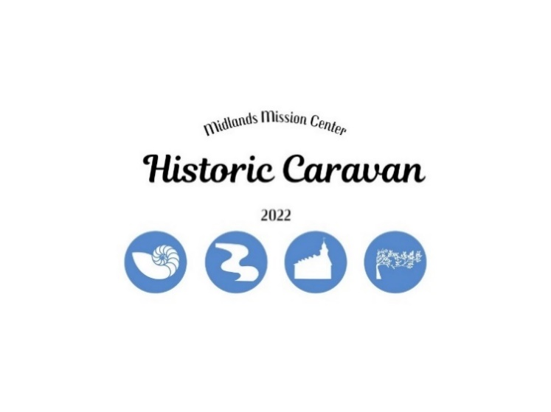

7615 Platte Purchase Dr, Suite 116 phone 816-221-4450

Kansas City, MO 64118 www.midlandsmc.org

7615 Platte Purchase Dr, Suite 116 phone 816-221-4450

Kansas City, MO 64118 www.midlandsmc.org

**WORLD CHURCH UPDATES**

World Church and Historical Foundation sites and buildings are OPEN! The new Community of Christ website, Our Ministry Tools, and Herald House website are also up and running. To gain access to church leadership materials, visit [cofchrist.org/our-ministry-tools](http://www.cofchrist.org/our-ministry-tools).

Community Labyrinth Walk

**6 – 8 pm Saturday July 9**

### Join The Center for Living Water for an in-person labyrinth walk with live music on the rooftop of the Temple.

Camp MITIOG @ Doniphan

**July 24 – 30**

### Come join the MITIOG family! Individuals age 16 and older can serve as counselors. The camp serves children with spina bifida and utilizes a 1 to 1 ratio of campers to counselors. It is a rewarding experience that promises to produce a lifetime of memories. Please consider a gift of time to this worthy cause. To apply visit [www.CampMitiog.org](http://www.CampMitiog.org). For more information contact Gary Libeer at [director@campmitiog.org](mailto:director@campmitiog.org) or 816.436.3913.

### DESCRIPTION: Man wearing tight sackcloth CAPTION: OH MAN ... THIS SACKCLOTH TOTALLY FIT ME THE LAST TIME I WORE IT

Summer Camp Registration is LIVE!!!

Go to [www.midlandsmc.org](http://www.midlandsmc.org/) and click the blue “Camp Registration” button.

Experience Reunion!!!

Something for everyone! Come join for family fun, fellowship, fishing, swimming, campfires, canteen, classes, boating, good food, study, and wonderful guest ministry.

**Doniphan** – Excelsior Springs, MO – June 29 to July 3

[](https://www.google.com/url?sa=i&rct=j&q=&esrc=s&source=images&cd=&cad=rja&uact=8&ved=2ahUKEwj3xuWJ0_7YAhUC5GMKHagWBdkQjRx6BAgAEAY&url=https://pixabay.com/en/camping-humor-tent-humorous-23792/&psig=AOvVaw1NczEahqtV6Pbew_roVTqH&ust=1517366023418722)Guest Ministers: Jim and Sharon Hannah

Planning Committee meets Monday evenings

**Chihowa** – Perry, KS – July 10 to 15

Guest Ministers: Brian and Sara Tubbesing

Planning Committee meets Sunday evenings

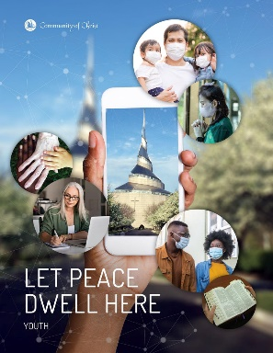

**WE NEED YOUR HELP!** *Please email*

[*khnatyshyn@cofchrist.org*](mailto:khnatyshyn@cofchrist.org) *to join a planning committee or share your*

*ministry.* **Nursery workers must be

Youth Worker certified.

2022 Reunion Prices

Adults (age 18+) $240

Youth (age 13-17) $125

Children (age 5-12) $75

Children (age 0-4) $25

Camperships Are Available

2022 Summer Camping Schedule

June 2 – 12 Senior High Caravan July 10 – 15 Reunion @ Chihowa

June 19 – 23 JR Camp @ Chihowa July 16 – 23 Spectacular @ GU

June 19 – 24 MS Camp @ Chihowa July 24 – 30 Mitiog @ Doniphan

June 29 – July 3 Reunion @ Doniphan July 28 – 30 Youth Quest @ TBD