
Bethel Congregation
Midlands Mission Center
Welcoming the online community
Kansas City, KS
December 14, 2025 10:30AM CDT
The Promise of Joy
Presiding High Priest Stan Troeh
Announcements
Welcome
Carol “Hark! The Herald Angels Sing” CCS #423
Advent Focus Joyce Shipley
Invitation to Worship Luke 2:7-11
⁷ And she gave birth to her firstborn son and wrapped him in bands of cloth, and laid him in a manger, because there was no place for them in the inn.
⁸ In that region there were shepherds living in the fields, keeping watch over their flock by night. ⁹ Then an angel of the Lord stood before them, and the glory of the Lord shone around them, and they were terrified. ¹⁰ But the angel said to them, “Do not be afraid; for see--I am bringing you good news of great joy for all the people: ¹¹ to you is born this day in the city of David a Savior, who is the Messiah, the Lord.
*Opening Hymn “Go, Tell It on the Mountain” CCS #409
*Invocation
*Response
USA Leadership Greetings
Make Disciples, Confront Oppression, Create Change
through transformative action (CCS #406)
Prayer for Peace Kaylee Baggerly
Loving God,
As we contemplate the real meaning of Christmas and the beautiful gift that you gave us, your son Jesus, let us meditate on the blessedness of that gift to our world and to our hearts, all those years ago.
Let that LOVE and JOY infiltrate our beings to bring us HOPE…. Hope for a brighter tomorrow and to bring us PEACE
- PEACE for our world, our countries, our communities
- PEACE for our congregations, far and wide
- PEACE for our families, our friends
- PEACE for the poor, the refugee, the homeless, the persecuted
- PEACE for ourselves…. Let PEACE begin with me…. as the words of the hymn go
We rejoice with you as we build Community, Communities of JOY, HOPE, LOVE and PEACE, in prayer, music, scripture and our daily actions Bring us even closer to your divine presence, enabling us to become inspired and creative in our endeavor to serve you with JOY. In the name of the Prince of PEACE we pray. Amen.
—Robyn Rankin, Wingham, New South Wales, Australia
Hymn “Bring Forth the Kingdom” CCS #387
Advent Message Seventy Kyle Joyce
Hymn “Canticle of the Turning” CCS #404
Disciples’ Generous Response https://bit.ly/BethelGift
Community of Christ upholds the enduring principle of Grace and Generosity. This means God’s grace, especially as revealed in Jesus Christ, is generous and unconditional. This means having received God’s generous grace, we respond generously and graciously receive the generosity of others. This means we offer all we are and have to God’s purposes as revealed in Jesus Christ. This means we generously share our witness, resources, ministries, and sacraments according to our true capacity.
In response to the grace and generosity we have found in God we get the opportunity to joyfully respond in sharing with others, the church and the earth our own outpouring of gratitude and generosity for being found and for what the Lord has done. How can you share generously today?
*Closing Hymn “Joy to the World” CCS #408
*Closing Prayer

*Congregation invited to stand

Bethel Community of Christ bethel.forthrightsystems.com
Pastor Rob de Zwart
Financial Officer Jeff Cady
Media Host David Troeh
CCS: Community of Christ Sings, ©2013, Herald Publishing House
NRSV: New Revised Standard Version, ©1989, Oxford
University Press, Inc. Used by permission. All rights reserved.
Permission to podcast/stream the music and text in this
service obtained from One License with license A-727171.
Announcements
- Sunday 12/14 9:45 am Business Meeting (officers, budget)
10:30 am The Promise of Joy with Kyle Joyce
- Monday 12/15 7:00 pm Priesthood Meeting (949 9683 2354)
- Thursday 12/18 7:00 pm Ministry of the Teacher lesson 5&6
Sunday zoom
- Sunday 12/21 9:45 am Lectionary Disc. – Matthew 1:18-25
10:30 am The Promise of Love Rob de Zwart
- Our website, including weekly bulletin, web and zoom links bethel.forthrightsystems.com.
- Give through eTithing (https://www.cofchrist.org/give)
Optionally, search for Bethel, KS (link)
RECORDINGS
Hark! The Herald Angels Sing - CCS 423 - The Beyond the Walls Choir https://youtube.com/watch?v=QMzQ8WWBJds
Go, Tell It on the Mountain - CCS 409 - The Beyond the Walls Choir https://youtube.com/watch?v=0GaGHpEOSA0
Bring Forth the Kingdom - CCS 387 - The Beyond the Walls Choir https://youtube.com/watch?v=tyUsFgy6zQ4
Canticle of the Turning - CCS 404 - The Beyond the Walls Choir https://youtube.com/watch?v=S7GAFySnkFs
Joy to the World! - CCS 408 - The Beyond the Walls Choir https://youtube.com/watch?v=Ow6mBSLbqT0
Lectionary
3-year cycle engaging significant portions of our Scripture.
This Week December 14 The Promise of Joy
Isaiah 35:1-10 Psalm 146:5-10
James 5:7-10 Matthew 11:2-11
Next Week December 21 The Promise of Love
Matthew 1:18-25/2:1-8 IV Isaiah 7:10-16
Psalm 80:1-7, 17-19 Romans 1:1-7

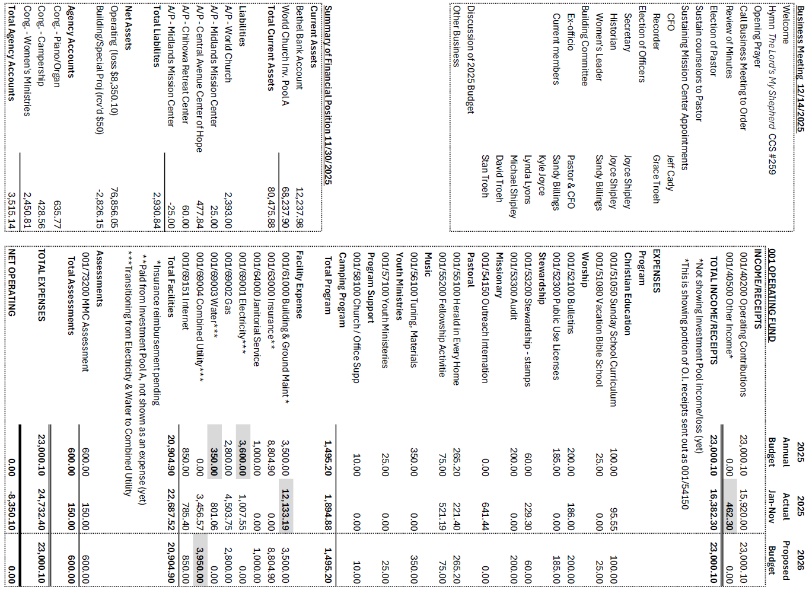


Online Ministry & Priesthood Classes
Center for Innovation in Ministry and Mission (CIMM)

To enroll or for more information on these classes and the certificate programs, visit graceland.edu/CIMM. Cost is $25 unless noted.

October 20 – December 14, 2025

- Introduction to Scripture – Daniel Nowiski
- Ministry of the Deacon – I. David Lloyd
- RCYW Core Training – I. David Lloyd

January 5 - March 1, 2026

- Introduction to PASTOR Ministry (ends Feb. 15)
- Ministry of the Disciple
- Christian Ministry Cert. Spiritual Formation – Kris Judd ($100)

CIMM Sessions are short seminars on topics of theology, culture, and Community of Christ Identity, Mission, Message, Beliefs and practices. These free sessions are broadcast live on Zoom at 7:00pm most Wednesdays. To register, visit www.graceland.edu/cimmsessions.
CENTER FOR LIVING WATER
www.centerforlivingwater.org

Grounded in the contemplative tradition of Christian spirituality, the Center for Living Water encourages attendees to seek spiritual transformation and peaceful living through practice and action.
- Sacred Flow: Mindful Community Yoga – 8pm 1st Wednesdays
- Conversation Café – 7pm 1st & 3rd Thursdays
- Soul Collage: Art & Soul – 7pm 3rd Tuesdays
- Sacred Pulse: Mindful Music – 6pm Dec 20

at

- Dec 3 –Ministry to the Unhoused – Gleen Johnson
- Dec 10 – Jesus as an Untouchable – Joshua Bennett
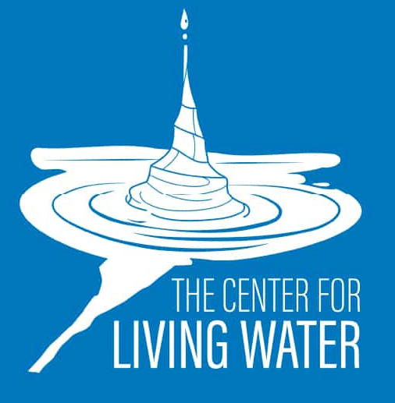
- Dec 17 – God with Us: Reclaiming the Truth of the Nativity: Unveiling the Theological Power Behind a Familiar Story – Dave Anderson

Central Mission Center Temple School Courses

- Intro to Scripture: 6:30 – 8:30 pm Mondays 1/5 to 2/9 @ Stone Church

More information and registration instructions can be found at centralmission.org/temple-school/.

7615 Platte Purchase Dr, Suite 116 presidentteam@midlandsmc.org
Kansas City, MO 64118 www.midlandsmc.org

ONLINE RESOURCES
The USA Mission Field has a new website! cofchristusa.org

eNews website: cofchrist.org/news/new-gathering-resources-website

Worship resources are in a new location on the “Gathering Resources” gathering.cofchrist.org/ Scroll down to “Lectionary Calendar” under “Plan”, then use the arrows to navigate to the correct month and date.

Huixqui Sisters Holiday Concert

Under the Spiral Concert Series

7pm Saturday, December 13

Pronounced like “whiskey”, this vocal duet originally from Huixquilucan, Mexico, is accompanied by guitar and keys. The duo creates custom arrangements of their favorite songs, with a vocal blend only achieved by sisters and vocal precision. Tickets are $20 each and can be reserved at bit.ly/SistersHolidayTix.

Autumn Lecture Series

Journey with us as we explore a number of fascinating individuals and topics from Community of Christ's past. More information and registration for each event can be found at bit.ly/AutumnLecture25.
- 7pm Tues, Dec 2 – "The Peter and Mary Whitmer Family and Diversity in the 1830s Church of Christ" with Mark Staker
- 7pm Thurs, Dec 4 – Cecil Ettinger's Journey to Nigeria" with David Ettinger

EMERGE Online Youth Gathering

6pm Sunday, December 28
All youth ages 14–18 are invited to join this Zoom gathering to connect, make new friends, and share life together with others across the church. Everyone is welcome, and we’d love to see you there! Zoom link: bit.ly/EmergeDec2025

Peace Colloquy: Houselessness & Community Action Ignites Sacred Action
This fall, Midlands and Central Mission Centers came together at the Community of Christ Temple for a transformative Peace Colloquy that invited disciples and seekers alike to embody faith as liberation in action.
The event, grounded in the theme “Building Bridges, Amplifying Voices & Taking Action,” offered more than conversation—it became a living testimony of what happens when we allow the Spirit to move among us with courage and compassion.

Participants heard stories of resilience and liberation: a trans musician whose honest sharing and song brought the sanctuary to tears; a woman courageously recounting her journey through houselessness after leaving an abusive marriage; and a group of young men, connected through Artists Helping the Homeless, whose compassion and service reflected Christ’s friendship that crosses every social line.

Attendees were not only inspired—they were activated. In keeping with the Colloquy’s call to “take action,” participants made tangible commitments to carry peace into their own communities. Since that weekend, members have registered as foster parents, attended city council meetings for the first time, and joined local efforts to support unhoused neighbors. Each pledge, large or small, has become a spark of divine liberation rekindled across our mission centers.

This year’s colloquy was more than an event—it was a movement of holy reawakening. A reminder that God’s Spirit still breathes through our collective action; that hope is not naïve, but grounded; that faith is not about perfection, but about showing up where love calls.

As one participant wrote afterward, “I left the colloquy believing again that change is possible—and that I have a role in it.”

May we continue to live unashamed of the gospel of liberating love.
May our peace be active, our justice courageous, and our hope stubborn enough to transform the world. Ending Houselessness is possible.

Peace and Justice Specialist, Jess Pycior

