
Bethel Congregation
Midlands Mission Center
Welcoming the online community
Kansas City, KS
March 1, 2026 10:30AM CDT
Faithfully Question
Presiding Elder Kristine Shipley
Announcements
Welcome
Invitation to Worship Psalm 121
I lift up my eyes to the hills—from where will my help come?
My help comes from the Lord, who made heaven and earth.
He will not let your foot be moved;
he who keeps you will not slumber.
He who keeps Israel will neither slumber nor sleep.
The Lord is your keeper;
the Lord is your shade at your right hand.
The sun shall not strike you by day nor the moon by night.
The Lord will keep you from all evil; he will keep your life.
The Lord will keep your going out and your coming in
from this time on and forevermore.
*Hymn “As the Wind Song through the Trees” CCS #42
*Invocation
*Response
Lenten Focus Moment Joyce Shipley
Prayer for Peace
God wants shalom. Shalom exists when all creation experiences justice, wholeness, and peace. God’s shalom is revealed in Christ’s peace. When we just take time to know someone else, we help create peace, justice draws near, and the world begins to change. You see, God’s kingdom isn’t just you, or just me—it is us, everyone. I have peace when you have peace. God’s love connects us. Christ’s presence invites shalom. May we commit to nurture justice and peace every day.
God of Peace,
You bring light to our darkness
and hope to our determined core.
Embolden us as we yearn for peace.
Direct us as we watch for peace.
Reassure us as we work for peace.
You are the light!
You are our peace!
Amen.
Hymn “Take the Path of the Disciple” CCS #558
Communion Message Elder Jeff Cady
Hymn “The Love of God” CCS #210
**Blessing and Serving of the Bread and Wine
Disciples’ Generous Response https://bit.ly/BethelGift
*Hymn “Come, Thou Fount of Every Blessing” CCS #87
*Sending Forth Romans 4:13,16
For the promise that he would inherit the world did not come to Abraham or to his descendants through the law but through the righteousness of faith. For this reason the promise depends on faith, in order that it may rest on grace, so that it may be guaranteed to all his descendants, not only to the adherents of the law but also to those who share the faith of Abraham…
*Congregation invited to stand
**Congregation invited to kneel
Bethel Community of Christ bethel.forthrightsystems.com
Pastor Rob de Zwart
Financial Officer Jeff Cady
Media Host David Troeh
CCS: Community of Christ Sings, ©2013, Herald Publishing House
NRSV: New Revised Standard Version, ©1989, Oxford
University Press, Inc. Used by permission. All rights reserved.
Permission to podcast/stream the music and text in this
service obtained from One License with license A-727171.
Announcements
- Sunday 3/1 9:45 am Lectionary Disc. – John 3:1-16
10:30 am Faithfully Question – Jeff Cady
- Tuesday 3/3 7:00 pm Together Tuesday (924 6108 0153)
- Sunday 3/8 9:45 am Lectionary Disc. – Romans 5:1-11
10:30 am Faithfully Reconcile
Sandy Billings speaking
- Our website, including weekly bulletin, web and zoom links bethel.forthrightsystems.com.
- Give through eTithing (https://www.cofchrist.org/give)
Optionally, search for Bethel, KS (link)
Recordings
As the Wind Song through the Trees - CCS 42 - The Beyond the Walls Choir https://youtube.com/watch?v=dXcn6brw7dg
CCS 558 - Take the Path of the Disciple - Music, Lyrics, Voices, Video https://youtube.com/watch?v=vd4jMokZQAw
Come, Thou Fount of Every Blessing - CCS 87 - The Beyond the Walls Choir https://youtube.com/watch?v=4O45QNfa9So
Lectionary
3-year cycle engaging significant portions of our Scripture.
This Week March 1 Faithfully Question
John 3:1-17 Genesis 12:1-4a
Psalm 121 Romans 4:1-5, 13-17
Next Week March 8 Faithfully Reconcile
Romans 5:1-11 Exodus 17:1-7
Psalm 95 John 4:5-42
Midlands Spring Retreat & Conference
April 24-26
We will focus on Momentum.
We hope for momentum in our congregations, momentum in our mission center, and momentum in our individual lives, including in our journey with God.

*Please encourage members and friends of your congregation to attend. We think it will be a restful and inspiring weekend together. More to come! Here's the registration link to the retreat. -Rob

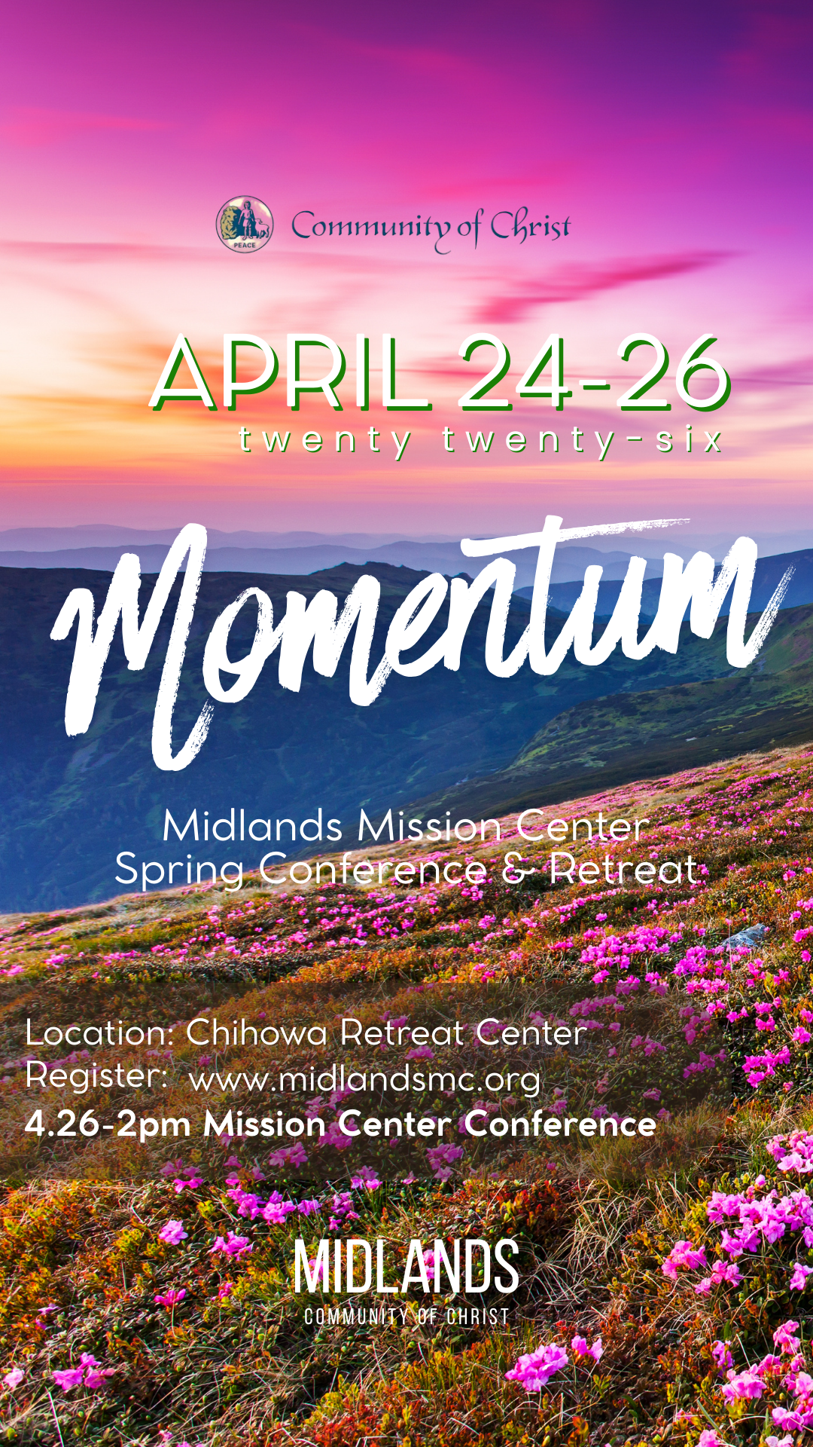
Registration QR, link
https://pci.jotform.com/form/260544721815052



Online Ministry & Priesthood Classes
Center for Innovation in Ministry and Mission (CIMM)

To enroll or for more information on these classes and the certificate programs, visit graceland.edu/CIMM. Cost is $25 unless noted.

March 2 – April 26
Summer 2026
June 5–16 Caravan July 12–19 Spectacular
June 18–22 Doniphan Family Camp July 12–17 MITIOG
June 28–July 3 Junior/Middle School Camp July 23–25 Youth Quest
July 5–10 Chihowa Family Camp

- Introduction to Priesthood Ministry
- Ministry of the Teacher – David Lloyd
- Ministry of the Seventy – Bethany Lloyd
- Ministry of the Bishop – Carla Long
- Christian Ministry Cert. Introduction to New Testament - Tony & Charmaine Chvala-Smith ($100)
CARAVAN 2026

We Are One in the Spirit!

Students who have completed grades 9–12 are invited on this 12-day quest to immerse ourselves in our Enduring Principles as we journey. We will spend the first half of our trip visiting Nauvoo, Kirtland, and the Sacred Grove in Palmyra learning about our Church history and where we came from. The second half of this exciting expedition will include exploring who we are as a faith community today and what we as disciples can do to live the Enduring Principles as we move into the future. We will visit the National Mall and the Smithsonian museums in Washington DC, Monticello in Virginia, the Beck Cultural Exchange Center in Knoxville TN, the Nashville Zoo, and the Lorraine Motel Civil Rights Museum in Memphis. We end with a Temple tour the last day.
Registration opens soon!

at
CIMM Sessions are short seminars on topics of theology, culture, and Community of Christ Identity, Mission, Message, Beliefs and practices. These free sessions are broadcast live on Zoom at 7:00pm most Wednesdays. To register, visit www.graceland.edu/cimmsessions.

- March 4 – Creating a Welcoming and Affirming Community through Harmony – Andy Markle
- March 11 – So Many Meanings to Jesus’s Death – Tony & Charmaine Chvala-Smith
- March 25 – Sacraments as Trail Markers – David Lloyd



7615 Platte Purchase Dr, Suite 116 presidentteam@midlandsmc.org
Kansas City, MO 64118 www.midlandsmc.org

MMC Spring Conference
Save the date April 24-26 for a mission center retreat at Chihowa culminating with spring conference 2pm Sunday, April 26. More information and registration to come at www.midlandsmc.org!
Young Adult Sundays

6 pm Sundays, beginning March 1

Church doesn't always happen in a building. YAM (Young Adult Ministries) Sundays are a place to explore our faith without judgement or expectations, offering a weekly Sunday experience for everyone. These gatherings will be different each week but follow a rotation of various avenues of spiritual exploration. For more information or the Zoom link, email mphillippe@cofchrist.org.

EMERGE Online Youth Gathering

6pm Sunday, March 22

All youth ages 14–18 are invited to join this Zoom gathering to connect, make new friends, and share life together with others across the church. Everyone is welcome, and we’d love to see you there! Check the CofChrist website event page for a Zoom link.

Silent Retreat @ Camp Ozark

The Mystery of Silence: Be Still and Know

March 13 – 15
The South Central States Mission Center invites you to participate in a weekend SILENT SPIRITUAL RETREAT at Camp Ozark south of Joplin, MO. Evangelist Paul Beaulieu and the SCS Mission Center Team will facilitate the retreat. The $90 registration fee includes food and lodging. More information and registration form at bit.ly/SilentRetreatMar26 Payment can be made at the retreat, but registration must be sent beforehand.
No Kings Rally

M
12 – 3 pm Saturday, March 28

Join JPATKC at the No Kings 3.0 Rally. Meet 100 feet due east of the horse fountain at Mill Creek Park at The Plaza, 47th Mill Creek Parkway. Wear your JPATKC shirt and join your voice with other Kansas Citizens concerned about chaos, corruption, and cruelty. To purchase a $20 shirt, contact Geri Norman at jpatkc@gmail.com.

Chihowa Workday(s)

M
April 11 and April 13 – 17
Please join us anytime on Saturday April 11 to help prepare the grounds for the upcoming summer camping season. Jobs include painting, planting trees, cutting trees and brush, and more. Bring tools or show up ready to be assigned a job. The church RV Association will be on the grounds April 13-17, and you are also welcome to come out anytime during that week to join 25+ individuals giving their time and talent to upkeep our valuable campgrounds.
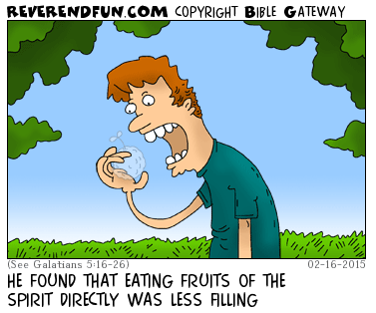
from the desk of
Rob Heverling

RELENTLESS
We moved into our new house.
In less than a week three different security company representatives loudly knocked on our door and rang our doorbell. Each one selling the value of their security system.
The first two salespeople had well researched, well-rehearsed pitches.
The third salesman was much younger than the other two. He didn't make a hard pitch at all.
He told me about himself, where he lived, and how he came to be employed by this company.
He asked what I did for a living and what I was passionate about.
I briefly told him about my work history and how I came to my current job as Midlands Mission Center President and why this was meaningful to me.
I told him how for the first time in several years we lived close to our kids and grandkids, and this was one of our passions! He listened.
Then he told me about how much he enjoyed hanging out with the young kids of his older sister and brother. He really liked being the cool uncle.
Eventually he made his lowkey security system pitch.
I liked this young man. As we talked, he genuinely seemed interested in my life.
And I was interested in his life. He felt authentic. I told him door-to-door sales was really challenging, but if he was good at sales, there was a real opportunity to be financially successful.
I declined his security system offer.
We declined every offer.

The third salesman asked after a few months, when we were settled in, could he come back for a visit?
"Of course!" I said, "It was good to get to know you a little."
Now, unless something changes dramatically, we don't plan on investing in a complete security system. But again, I really liked the young man. I suppose there's a chance he might change our minds, but really, I simply would like to convert his interest in selling me a security system into a budding friendship.
It's too soon to tell, but perhaps he knows his investment in me is part of a relentlessness that is often a necessity for closing a deal.
I have learned being relentless is critical in demonstrating genuine care for others and (eventually) inviting people into being part of the Community of Christ.
This is no Art of the Deal.
This is a relentless pursuit of building trust, companionship, and love for other people who could be changed by being in relationship with us and discovering how meaningful our unique community and mission can be in their lives.

It's not really about saving souls; it's about inviting people to allow us to be part of their unique faith journey or helping them start their journey. And guiding them to experience the power of a Spirit-led community.

Be RELENTLESS! Be unyieldingly persistent in building authentic relationships with new people that can end up with an invitation that just might be too meaningful to decline.

Shalom, shalom, Rob
