
Bethel Congregation
Midlands Mission Center
Welcoming the online community
Kansas City, KS
March 22, 2026 10:30AM CDT
Faithfully Breathe
Presiding Priest Sandra Billings
Welcome and Announcements
Call to Worship
Lent is about divine grace. It is a time to reflect on our discipleship and prepare for Easter. It is based on the example of Christ’s forty days in the desert preparing for ministry. Lent is a time to honestly examine who we are, recognize who we are called to become, and receive divine grace for the journey in between. Lent is an invitation to fast or replace a behavior with time connecting with God.
Unison reading 2 Nephi 3:32–34, adapted
My soul grieves because of my sin. I am surrounded by the temptations that so easily influence me. When I desire to rejoice, my heart groans because of my sins; Nevertheless, I know in whom I have trust.
Lenten Worship Moment: 2 Kingdoms
Scripture Reading Luke 12:31-34
First Reading: What words, phrases, or images stand out?
Second Reading: What might God be whispering to you?
Hymn “Seek First” CCS #600
Lenten Focus Moment Joyce Shipley
Hymn of Shalom “Blest Be the Tie that Binds” CCS #325
Prayer for Peace
Participants become part of this prayer by silently inserting words or phrases to complete the thoughts.
O Holy One, forgive us for… Pause.
Giver of life, forgive us for… Pause.
Lover of souls, renew us through… Pause.
Filler of hearts, renew us through… Pause.
Standard of peace, strengthen us with… Pause.
Champion of the lowly, strengthen us with… Pause.
Divine Creator, we ask for peace in our… Pause.
Blessed Redeemer, we ask for peace in our… Pause.
Lord, God Almighty, we will sue for your peace by… Pause.
Amen. And amen.
Hymn “One Common Prayer” CCS #313, twice
Message Elder Rob de Zwart
Disciples’ Generous Response https://bit.ly/BethelGift
We Journey Read in unison
During the coming week, we will focus on wholeness as individuals and as a community. We celebrate all aspects of creation and take our place as caregivers of Christ’s peace. We welcome God’s peaceable kingdom in our hearts, and in our lives. Help us recognize your surprising grace. Grant us strength to see clearly where we are, and courage to step where you beckon us to go. Our journey requires honesty, humility, hopefulness, healing, and wholeness. Breathe your Spirit on us. Make us whole—make us yours.
*Hymn “Rain Down” CCS #260
*Prayer for Wholeness
*Postlude

*Congregation invited to stand

Bethel Community of Christ bethel.forthrightsystems.com
Pastor Rob de Zwart
Financial Officer Jeff Cady
Media Host David Troeh
CCS: Community of Christ Sings, ©2013, Herald Publishing House
NRSV: New Revised Standard Version, ©1989, Oxford
University Press, Inc. Used by permission. All rights reserved.
Permission to podcast/stream the music and text in this
service obtained from One License with license A-727171.

Announcements
- Sunday 3/22 9:45 am Lectionary Disc. – Eze 37:1-14
10:30 am Faithfully Breathe–Rob de Zwart
- Sunday 3/29 9:45 am Lectionary Disc. – Matt 21:1-11
10:30 am Faithfully Enter–Rob Heverling
Potluck following service
- Our website, including weekly bulletin, web and zoom links bethel.forthrightsystems.com.
- Give through eTithing (https://www.cofchrist.org/give)
Optionally, search for Bethel, KS (link)
Midlands Highlights
April 24-26 Midlands Spring Conference Retreat
June 5-16 Sr High Caravan
Recordings
Blest Be the Tie that Binds (a cappella) - CCS 325 - The Beyond the Walls Choir https://youtube.com/watch?v=I7aVOslgIAU
Rain Down (2021) - CCS 260 - The Beyond the Walls Choir https://youtube.com/watch?v=vPF3chvC_cI
Lectionary
3-year cycle engaging significant portions of our Scripture.
This Week March 22 Faithfully Breathe
Ezekiel 37:1-14 Psalm 130
Romans 8:6-11 John 11:1-45
Next Week March 29 Faithfully Enter (Palm Sunday)
Matthew 21:1-11 Psalm 118:1-2, 19-29
Faithfully Empty (Passion Sunday)
Phil. 2:5-11 Isa. 50:4-9a Ps 31:9-16 Matt 26:14-27:66
April 2 Maundy Thursday Faithfully Remember
John 13:1-17, 31b-35 Exo. 12:1-14 Ps 116:1-2, 12-19
1 Corinthians 11:23-26
April 3 Good Friday Faithfully Lament
John 18:1-19:42 Isa. 52:13-53:12 Ps 22 Heb 10:16-25
April 4 Holy Saturday Faithfully Wait
John 19:38-42 Job 14:1-14 Ps 31:1-4, 15-16 1 Pet 4:1-8
Midlands Spring Retreat & Conference
April 24-26
We will focus on Momentum.
We hope for momentum in our congregations, momentum in our mission center, and momentum in our individual lives, including in our journey with God.

*Please encourage members and friends of your congregation to attend. We think it will be a restful and inspiring weekend together. More to come! Here's the registration link to the retreat. -Rob

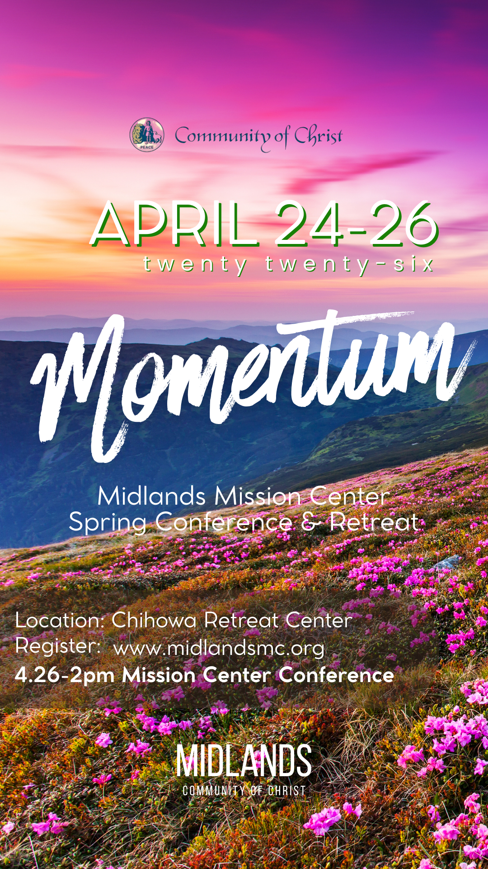
Registration QR, link
https://pci.jotform.com/form/260544721815052



Online Ministry & Priesthood Classes
Center for Innovation in Ministry and Mission (CIMM)

To enroll or for more information on these classes and the certificate programs, visit graceland.edu/CIMM. Cost is $25 unless noted.

March 2 – April 26
Summer 2026
June 5–16 Caravan July 12–19 Spectacular
June 18–22 Doniphan Family Camp July 12–17 MITIOG
June 28–July 3 Junior/Middle School Camp July 23–25 Youth Quest
July 5–10 Chihowa Family Camp

- Introduction to Priesthood Ministry
- Ministry of the Teacher – David Lloyd
- Ministry of the Seventy – Bethany Lloyd
- Ministry of the Bishop – Carla Long
- Christian Ministry Cert. Introduction to New Testament - Tony & Charmaine Chvala-Smith ($100)
CARAVAN 2026

We Are One in the Spirit!

Students who have completed grades 9–12 are invited on this 12-day quest to immerse ourselves in our Enduring Principles as we journey. We will spend the first half of our trip visiting Nauvoo, Kirtland, and the Sacred Grove in Palmyra learning about our Church history and where we came from. The second half of this exciting expedition will include exploring who we are as a faith community today and what we as disciples can do to live the Enduring Principles as we move into the future. We will visit the National Mall and the Smithsonian museums in Washington DC, Monticello in Virginia, the Beck Cultural Exchange Center in Knoxville TN, the Nashville Zoo, and the Lorraine Motel Civil Rights Museum in Memphis. We end with a Temple tour the last day.
Registration opens soon!

at
CIMM Sessions are short seminars on topics of theology, culture, and Community of Christ Identity, Mission, Message, Beliefs and practices. These free sessions are broadcast live on Zoom at 7:00pm most Wednesdays. To register, visit www.graceland.edu/cimmsessions.

- March 4 – Creating a Welcoming and Affirming Community through Harmony – Andy Markle
- March 11 – So Many Meanings to Jesus’s Death – Tony & Charmaine Chvala-Smith
- March 25 – Sacraments as Trail Markers – David Lloyd



7615 Platte Purchase Dr, Suite 116 presidentteam@midlandsmc.org
Kansas City, MO 64118 www.midlandsmc.org

MMC Spring Conference
Save the date April 24-26 for a mission center retreat at Chihowa culminating with spring conference 2pm Sunday, April 26. More information and registration to come at www.midlandsmc.org!
Young Adult Sundays

6 pm Sundays, beginning March 1

Church doesn't always happen in a building. YAM (Young Adult Ministries) Sundays are a place to explore our faith without judgement or expectations, offering a weekly Sunday experience for everyone. These gatherings will be different each week but follow a rotation of various avenues of spiritual exploration. For more information or the Zoom link, email mphillippe@cofchrist.org.

EMERGE Online Youth Gathering

6pm Sunday, March 22

All youth ages 14–18 are invited to join this Zoom gathering to connect, make new friends, and share life together with others across the church. Everyone is welcome, and we’d love to see you there! Check the CofChrist website event page for a Zoom link.

Silent Retreat @ Camp Ozark

The Mystery of Silence: Be Still and Know

March 13 – 15
The South Central States Mission Center invites you to participate in a weekend SILENT SPIRITUAL RETREAT at Camp Ozark south of Joplin, MO. Evangelist Paul Beaulieu and the SCS Mission Center Team will facilitate the retreat. The $90 registration fee includes food and lodging. More information and registration form at bit.ly/SilentRetreatMar26 Payment can be made at the retreat, but registration must be sent beforehand.
No Kings Rally

M
12 – 3 pm Saturday, March 28

Join JPATKC at the No Kings 3.0 Rally. Meet 100 feet due east of the horse fountain at Mill Creek Park at The Plaza, 47th Mill Creek Parkway. Wear your JPATKC shirt and join your voice with other Kansas Citizens concerned about chaos, corruption, and cruelty. To purchase a $20 shirt, contact Geri Norman at jpatkc@gmail.com.

Chihowa Workday(s)

M
April 11 and April 13 – 17
Please join us anytime on Saturday April 11 to help prepare the grounds for the upcoming summer camping season. Jobs include painting, planting trees, cutting trees and brush, and more. Bring tools or show up ready to be assigned a job. The church RV Association will be on the grounds April 13-17, and you are also welcome to come out anytime during that week to join 25+ individuals giving their time and talent to upkeep our valuable campgrounds.
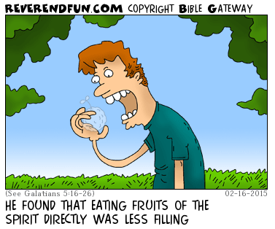
from the desk of
Rob Heverling

RELENTLESS
We moved into our new house.
In less than a week three different security company representatives loudly knocked on our door and rang our doorbell. Each one selling the value of their security system.
The first two salespeople had well researched, well-rehearsed pitches.
The third salesman was much younger than the other two. He didn't make a hard pitch at all.
He told me about himself, where he lived, and how he came to be employed by this company.
He asked what I did for a living and what I was passionate about.
I briefly told him about my work history and how I came to my current job as Midlands Mission Center President and why this was meaningful to me.
I told him how for the first time in several years we lived close to our kids and grandkids, and this was one of our passions! He listened.
Then he told me about how much he enjoyed hanging out with the young kids of his older sister and brother. He really liked being the cool uncle.
Eventually he made his lowkey security system pitch.
I liked this young man. As we talked, he genuinely seemed interested in my life.
And I was interested in his life. He felt authentic. I told him door-to-door sales was really challenging, but if he was good at sales, there was a real opportunity to be financially successful.
I declined his security system offer.
We declined every offer.

The third salesman asked after a few months, when we were settled in, could he come back for a visit?
"Of course!" I said, "It was good to get to know you a little."
Now, unless something changes dramatically, we don't plan on investing in a complete security system. But again, I really liked the young man. I suppose there's a chance he might change our minds, but really, I simply would like to convert his interest in selling me a security system into a budding friendship.
It's too soon to tell, but perhaps he knows his investment in me is part of a relentlessness that is often a necessity for closing a deal.
I have learned being relentless is critical in demonstrating genuine care for others and (eventually) inviting people into being part of the Community of Christ.
This is no Art of the Deal.
This is a relentless pursuit of building trust, companionship, and love for other people who could be changed by being in relationship with us and discovering how meaningful our unique community and mission can be in their lives.

It's not really about saving souls; it's about inviting people to allow us to be part of their unique faith journey or helping them start their journey. And guiding them to experience the power of a Spirit-led community.

Be RELENTLESS! Be unyieldingly persistent in building authentic relationships with new people that can end up with an invitation that just might be too meaningful to decline.

Shalom, shalom, Rob
