
Bethel Congregation
Midlands Mission Center
Welcoming the online community
Kansas City, KS
March 29, 2026 10:30AM CDT
Faithfully Enter
Presiding High Priest Stan Troeh
Gathering Hymn “Filled with Excitement” CCS #465
Announcements
Welcome
Invitation to Worship
⁷ they brought the donkey and the colt and put their cloaks on them, and he sat on them. ⁸ A very large crowd spread their cloaks on the road, and others cut branches from the trees and spread them on the road. ⁹ The crowds that went ahead of him and that followed were shouting, “Hosanna to the Son of David! Blessed is the one who comes in the name of the Lord! Hosanna in the highest heaven!”
*Hymn “No Tramp of Soldier’s Marching Feet” CCS #466
*Invocation Grace Troeh
Lenten Focus Moment Joyce Shipley
Prayer for Peace Ylva Hup
Dear God, Thank you for Your peace that surpasses all understanding. In times of uncertainty and unrest, we seek Your peace to calm troubled hearts, weary souls, and worn-torn lands. When we’ve lost hope, may Your peace remind us that You are in complete control, and will continue to lead us. May Your peace bring clarity where there is doubt, joy where there is sorrow, and hope where there is hopelessness. Despite what our eyes see daily on the news, thank you for your peace that revives our hope, trust, and confidence in You.
When our minds are anxious, may Your peace strengthen and sustain us. Thank you for your peace that brings stillness to our storms. Your peace also reminds us that You are always present and will continue to lead us through challenging times. When our hearts, minds, and spirits are restless, thank you for Your peace that bring us rest and calm. When our minds wander, thank you for Your peace that redirects us back to You. In Jesus’ name, Amen.
Hymn “Christ Leads” CCS #28
Morning Message Seventy Rob Heverling
Hymn “Who Is This Jesus?” CCS #38
Disciples’ Generous Response https://bit.ly/BethelGift
Sending Forth Doctrine and Covenants 161:1-2
*Hymn “My Savior Said That I Should Be” CCS #589
*Closing Prayer & Blessing on Potluck

*Congregation invited to stand

Bethel Community of Christ bethel.forthrightsystems.com
Pastor Rob de Zwart
Financial Officer Jeff Cady
Media Host David Troeh
CCS: Community of Christ Sings, ©2013, Herald Publishing House
NRSV: New Revised Standard Version, ©1989, Oxford
University Press, Inc. Used by permission. All rights reserved.
Permission to podcast/stream the music and text in this
service obtained from One License with license A-727171.

Announcements
- Sunday 3/29 9:45 am Lectionary Disc. – Matt 21:1-11
10:30 am Faithfully Enter–Rob Heverling
Potluck following service
- Tuesday 3/31 7:00 pm Together Tuesday (924 6108 0153)
- Thursday 4/2 7:00 pm Maundy Thursday (Bethel)
- Friday 4/3 7:00 pm Good Friday (Leavenworth)
- Sunday 4/5 9:30 am EASTER BREAKFAST
10:30 am Awake to New Life-Rob de Zwart
Hybrid Communion
- Our website, including weekly bulletin, web and zoom links bethel.forthrightsystems.com.
Midlands Highlights
April 24-26 Midlands Spring Conference Retreat
June 5-16 Sr High Caravan
Recordings
CCS 466 - No Tramp of Soldiers' Marching Feet - Music Text Vocals https://youtube.com/watch?v=QqMf0AJFV7s
CCS 38 - Who Is This Jesus - Music Lyrics and Voices https://youtube.com/watch?v=xcJl6uygeSQ
Lectionary
3-year cycle engaging significant portions of our Scripture.
This Week March 29 Faithfully Enter (Palm Sunday)
Matthew 21:1-11 Psalm 118:1-2, 19-29
Faithfully Empty (Passion Sunday)
Phil. 2:5-11 Isa. 50:4-9a Ps 31:9-16 Matt 26:14-27:66
April 2 Maundy Thursday Faithfully Remember
John 13:1-17, 31b-35 Exo. 12:1-14 Ps 116:1-2, 12-19
1 Corinthians 11:23-26
April 3 Good Friday Faithfully Lament
John 18:1-19:42 Isa. 52:13-53:12 Ps 22 Heb 10:16-25
April 4 Holy Saturday Faithfully Wait
John 19:38-42 Job 14:1-14 Ps 31:1-4, 15-16 1 Pet 4:1-8
Next Week April 5 Awake to New Life (Easter)
John 20:1-18 Matthew 28:1-10 Jeremiah 31:1-6
Psalm 118:1-2, 14-24 Colossians 3:1-4
Midlands Spring Retreat & Conference
April 24-26
We will focus on Momentum.
We hope for momentum in our congregations, momentum in our mission center, and momentum in our individual lives, including in our journey with God.

*Please encourage members and friends of your congregation to attend. We think it will be a restful and inspiring weekend together. More to come! Here's the registration link to the retreat. -Rob

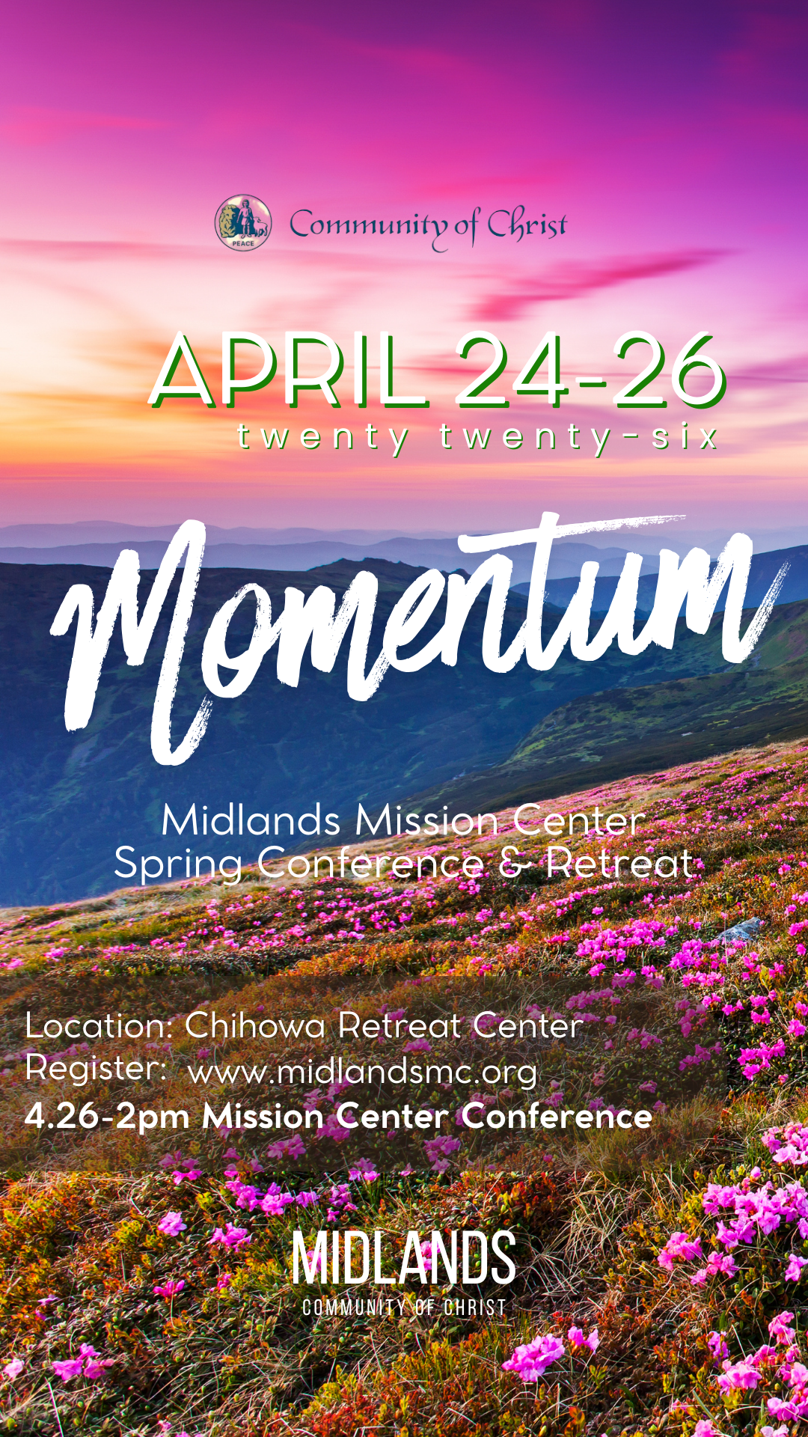
Registration QR, link
https://pci.jotform.com/form/260544721815052



Online Ministry & Priesthood Classes
Center for Innovation in Ministry and Mission (CIMM)

To enroll or for more information on these classes and the certificate programs, visit graceland.edu/CIMM. Cost is $25 unless noted.

March 2 – April 26
Summer 2026
June 5–16 Caravan July 12–19 Spectacular
June 18–22 Doniphan Family Camp July 12–17 MITIOG
June 28–July 3 Junior/Middle School Camp July 23–25 Youth Quest
July 5–10 Chihowa Family Camp

- Introduction to Priesthood Ministry
- Ministry of the Teacher – David Lloyd
- Ministry of the Seventy – Bethany Lloyd
- Ministry of the Bishop – Carla Long
- Christian Ministry Cert. Introduction to New Testament - Tony & Charmaine Chvala-Smith ($100)
CARAVAN 2026

We Are One in the Spirit!

Students who have completed grades 9–12 are invited on this 12-day quest to immerse ourselves in our Enduring Principles as we journey. We will spend the first half of our trip visiting Nauvoo, Kirtland, and the Sacred Grove in Palmyra learning about our Church history and where we came from. The second half of this exciting expedition will include exploring who we are as a faith community today and what we as disciples can do to live the Enduring Principles as we move into the future. We will visit the National Mall and the Smithsonian museums in Washington DC, Monticello in Virginia, the Beck Cultural Exchange Center in Knoxville TN, the Nashville Zoo, and the Lorraine Motel Civil Rights Museum in Memphis. We end with a Temple tour the last day.
Registration opens soon!

at
CIMM Sessions are short seminars on topics of theology, culture, and Community of Christ Identity, Mission, Message, Beliefs and practices. These free sessions are broadcast live on Zoom at 7:00pm most Wednesdays. To register, visit www.graceland.edu/cimmsessions.

- March 4 – Creating a Welcoming and Affirming Community through Harmony – Andy Markle
- March 11 – So Many Meanings to Jesus’s Death – Tony & Charmaine Chvala-Smith
- March 25 – Sacraments as Trail Markers – David Lloyd



7615 Platte Purchase Dr, Suite 116 presidentteam@midlandsmc.org
Kansas City, MO 64118 www.midlandsmc.org

MMC Spring Conference
Save the date April 24-26 for a mission center retreat at Chihowa culminating with spring conference 2pm Sunday, April 26. More information and registration to come at www.midlandsmc.org!
Young Adult Sundays

6 pm Sundays, beginning March 1

Church doesn't always happen in a building. YAM (Young Adult Ministries) Sundays are a place to explore our faith without judgement or expectations, offering a weekly Sunday experience for everyone. These gatherings will be different each week but follow a rotation of various avenues of spiritual exploration. For more information or the Zoom link, email mphillippe@cofchrist.org.

EMERGE Online Youth Gathering

6pm Sunday, March 22

All youth ages 14–18 are invited to join this Zoom gathering to connect, make new friends, and share life together with others across the church. Everyone is welcome, and we’d love to see you there! Check the CofChrist website event page for a Zoom link.

Silent Retreat @ Camp Ozark

The Mystery of Silence: Be Still and Know

March 13 – 15
The South Central States Mission Center invites you to participate in a weekend SILENT SPIRITUAL RETREAT at Camp Ozark south of Joplin, MO. Evangelist Paul Beaulieu and the SCS Mission Center Team will facilitate the retreat. The $90 registration fee includes food and lodging. More information and registration form at bit.ly/SilentRetreatMar26 Payment can be made at the retreat, but registration must be sent beforehand.
No Kings Rally

M
12 – 3 pm Saturday, March 28

Join JPATKC at the No Kings 3.0 Rally. Meet 100 feet due east of the horse fountain at Mill Creek Park at The Plaza, 47th Mill Creek Parkway. Wear your JPATKC shirt and join your voice with other Kansas Citizens concerned about chaos, corruption, and cruelty. To purchase a $20 shirt, contact Geri Norman at jpatkc@gmail.com.

Chihowa Workday(s)

M
April 11 and April 13 – 17
Please join us anytime on Saturday April 11 to help prepare the grounds for the upcoming summer camping season. Jobs include painting, planting trees, cutting trees and brush, and more. Bring tools or show up ready to be assigned a job. The church RV Association will be on the grounds April 13-17, and you are also welcome to come out anytime during that week to join 25+ individuals giving their time and talent to upkeep our valuable campgrounds.
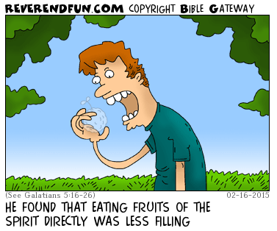
from the desk of
Rob Heverling

RELENTLESS
We moved into our new house.
In less than a week three different security company representatives loudly knocked on our door and rang our doorbell. Each one selling the value of their security system.
The first two salespeople had well researched, well-rehearsed pitches.
The third salesman was much younger than the other two. He didn't make a hard pitch at all.
He told me about himself, where he lived, and how he came to be employed by this company.
He asked what I did for a living and what I was passionate about.
I briefly told him about my work history and how I came to my current job as Midlands Mission Center President and why this was meaningful to me.
I told him how for the first time in several years we lived close to our kids and grandkids, and this was one of our passions! He listened.
Then he told me about how much he enjoyed hanging out with the young kids of his older sister and brother. He really liked being the cool uncle.
Eventually he made his lowkey security system pitch.
I liked this young man. As we talked, he genuinely seemed interested in my life.
And I was interested in his life. He felt authentic. I told him door-to-door sales was really challenging, but if he was good at sales, there was a real opportunity to be financially successful.
I declined his security system offer.
We declined every offer.

The third salesman asked after a few months, when we were settled in, could he come back for a visit?
"Of course!" I said, "It was good to get to know you a little."
Now, unless something changes dramatically, we don't plan on investing in a complete security system. But again, I really liked the young man. I suppose there's a chance he might change our minds, but really, I simply would like to convert his interest in selling me a security system into a budding friendship.
It's too soon to tell, but perhaps he knows his investment in me is part of a relentlessness that is often a necessity for closing a deal.
I have learned being relentless is critical in demonstrating genuine care for others and (eventually) inviting people into being part of the Community of Christ.
This is no Art of the Deal.
This is a relentless pursuit of building trust, companionship, and love for other people who could be changed by being in relationship with us and discovering how meaningful our unique community and mission can be in their lives.

It's not really about saving souls; it's about inviting people to allow us to be part of their unique faith journey or helping them start their journey. And guiding them to experience the power of a Spirit-led community.

Be RELENTLESS! Be unyieldingly persistent in building authentic relationships with new people that can end up with an invitation that just might be too meaningful to decline.

Shalom, shalom, Rob
