
Bethel Congregation
Midlands Mission Center
Welcoming the online community
Kansas City, KS
June 7, 2026 10:30AM CDT
Grow in Faith
Presiding Elder Kristine Shipley
Announcements
Welcome
*Hymn “Sing of Colors” CCS #332
Invitation to Worship
Leader: Can we trust you, God? When we’re surrounded by deceit and corruption?
Everyone: We can trust you, God. You love us, although we can’t really understand it.
Leader: Can we trust in your grace, God?
Everyone: Our trust in your grace leads to hope.
Leader: How can we have hope when living is difficult?
Everyone: Our faith bridges this uncertain world with you.
Leader: What can we do to really know your grace, God?
Everyone: We will try to grow strong in faith to really know your grace.
Leader: We have hope in you, God, because of your righteousness made known in the faith of Jesus, his life, his sacrifice, and his resurrection.
Prayer for Peace
God of weeping, we ask forgiveness for our failure as humanity to care for all. Our hearts break for the abused and hungry, the betrayed and bleeding, and the crying.
We are grateful that you weep, bleed, and cry with the oppressed. We pray that we would have the courage to do the same. May we open our hearts to the pain of the world, and in doing so may we help heal the world.
Help us listen so our nervous, certainty-craving minds would be open to new understandings of Christ. In the name of Jesus, the Way of peace. Amen.
Hymn “Come, Thou Fount of Every Blessing” CCS #87
Communion Message Elder Jeff Cady
Hymn “Breathe on Me, Breath of God” CCS #190
**Blessing and Service of the Sacraments
Disciples’ Generous Response https://bit.ly/BethelGifts
* Hymn “God Is Calling” CCS #172
*Sending Forth D&C 157:16b,17
Nevertheless, I have heard your prayers when you have cried out to me, and I have been with you in the places where you occupy. I am aware of your desires to serve me and my assurance is that as you go forth, your offerings of faith and service are acceptable to me.
In all your efforts, therefore, continue to trust in my grace and respond in love to the leadings of my Spirit. If you will come before me in unity and love I will bless you with a great outpouring of compassion, both for one another and for the world into which you are sent. Amen.
*Congregation invited to stand

Bethel Community of Christ bethel.forthrightsystems.com
Pastor Rob de Zwart
Financial Officer Jeff Cady
Media Host David Troeh
CCS: Community of Christ Sings, ©2013, Herald Publishing House
NRSVue: New Revised Standard Version updated edition, ©2021, Friendship Press, Inc. Used by permission. All rights reserved.
Permission to podcast/stream the music and text in this
service obtained from One License with license A-727171.
Announcements
- Sunday 6/7 9:45 am Lectionary Disc: Romans 4:13-25
10:30 am Grow in Faith—Elder Jeff Cady
- Tuesday 6/9 7:00 pm Together Tuesday (924 6108 0153)
- Thursday 6/11 2:00 pm Women’s Meeting
- Sunday 6/14 9:45 am Lectionary Disc: Gen 18:1-15; 21:1-7
10:30 am Grow in Possibilities—Sandy Billings
- Our website, including weekly bulletin, web and zoom links: bethel.forthrightsystems.com
- Give through eTithing (https://www.cofchrist.org/give)
Optionally, search for Bethel, KS (or use link)
Recordings
CCS 332 - Sing of Colors (De Colores) - Music Lyrics Voices and Video - Online Choir https://youtube.com/watch?v=5xqlDYN9sz8
Come, Thou Fount of Every Blessing - CCS 87 - The Beyond the Walls Choir https://youtube.com/watch?v=4O45QNfa9So
CCS 190 Breathe on Me Breath of God (Community of Christ Sings) https://youtube.com/watch?v=x-N8XhZkLQg
God Is Calling - CCS 172 - The Beyond the Walls Choir https://youtube.com/watch?v=OODqE7nWh6o
Lectionary
3-year cycle engaging significant portions of our Scripture.
This Week Jun 7 Grow in Faith
Romans 4:13-25 Genesis 12:1-9
Psalm 33:1-12 Matthew 9:9-13, 18-26
Next Week Jun 14 Grow in Possibilities
Genesis 18:1-15; 21:1-7 Psalm 116:1-2, 12-19
Romans 5:1-8 Matthew 9:35-10:8, (9-23)



Online Ministry & Priesthood Classes
Center for Innovation in Ministry and Mission (CIMM)

To enroll or for more information on these classes and the certificate programs, visit graceland.edu/CIMM. Cost is $25 unless noted.

June 29 – August 23
- Ministry of High Priest – Jennifer Killpack
- Ministry of Evangelist – Marava Arnaud & Kris Judd
CYW Core Training (continued from May 4)


CIMM Sessions are on summer break and fall schedules are coming soon!
World Church Facebook Group

We're excited to announce a new Facebook group hosted by the World Church Communications Team! Join to find event announcements, updates, and news from around the church. Platforms like Facebook and Instagram are now designed to reach people who don't follow us yet. This means our public pages are better for introducing Community of Christ to new people than for staying connected with those who already know us. The new Facebook group is where we'll connect directly with members, seekers, and friends. We encourage you to keep following and sharing from our public social media because every share helps more people find our message of Christ's peace. Join at bit.ly/CofCFBGroup.

at

SAVE THE DATE
What: Midlands Mission Center Fall Conference
When: Sunday, November 1, 2026
Where: Topeka Community of Christ
More details will be coming!


7615 Platte Purchase Dr, Suite 116 presidentteam@midlandsmc.org
Kansas City, MO 64118 www.midlandsmc.org

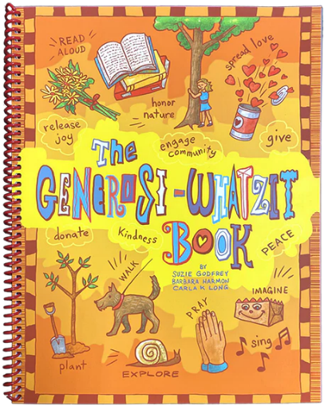
Book Recommendation
The Presiding Bishopric is promoting a new book to support both congregational life and family ministry. The Generosi-Whatzit Book invites us to shift the conversation from “What do I want?” to “How can I help?”—a question that can shape both discipleship and community life. It is an interactive guide to help families and congregations explore generosity as a way of life through simple, meaningful activities.
While designed for families, the resource also works well in Sunday school, small groups, youth settings, and intergenerational gatherings. Each section includes scripture, a guided activity, and reflection questions to support connection and conversation. The Generosi-Whatzit Book is available through Herald House at bit.ly/HHGenerosity and will be coming soon to Amazon.

Twist Weekend @ Topeka

Teens Working In Service Together

7pm Fri, Aug 28 – 12pm Sun, Aug 30

At TWIST, amongst all the FREE fun and fellowship of camp, 6th–12th grade campers learn the value of service and giving back to the community while participating in various service-related activities on Saturday. Please bring an insurance card copy and a completed health form found on the MMC website. Questions? Contact Dawn 816.718.8307 or Greg 816.210.4943 MMC_Youth@midlandsmc.org.

Historic Sites Tour to Australia

September 5 – 18

Trace the footsteps of the early missionaries and hear stories about Australia's founding church members. Visit the beautiful Tiona reunion ground as well as famous sites such as the Sydney Opera House, the Great Barrier Reef, and so much more! Extend your travels with optional pre- and/or post-tours filled with church history, scenic views, fellowship, and delicious foods. Information at bit.ly/CofCAustralia26.

International Peace Forum

Seeds of Peace: Environmental Justice and Action

October 16 – 18

The event builds on the tradition of the International Peace Colloquy, offering worship, learning, and community engagement. All are welcome! Registration is now open! cofchrist.org/peace-forum

Experience Summer Camp!!
Youth Camps 2026

June 5–16 Caravan $500 POSTPONED TO 2028
June 28–July 3 Junior/Middle School Camp $335 ($355 after 5/15)
July 12–19 Spectacular @ Graceland $495 ($595 after 6/30)
July 12–17 Camp MITIOG @ Doniphan
July 23–25 Youth Quest @ Olathe


Family Camps (Reunion)

Doniphan – Excelsior Springs, MO – June 18 to 22
Joint event with Central Missouri Mission Center
Guest Minister: Apostle Richard James

Chihowa – Perry, KS – July 5 to 10
Guest Minister: Tony & Charmaine Chvala-Smith
Directors: Dawn & Greg Bassett

Family Camp Prices (Early Bird/Regular)

Age Doniphan* Chihowa
Adults (age 16+) $360 $260
*Price for main lodge, cabins and RVs are cheaper
Youth (age 13-15) $320 $170
Children (age 5-12) $320 $125
Children (age 0-4) FREE $25
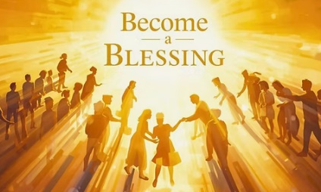

Register NOW
- YOUTH: www.midlandsmc.org/camps Find camp & click “Register Here”
- FAMILY CAMP www.midlandsmc.org/family : Find your camp and choose “Pay” now (credit card) or “PAY LATER” (check, cash, credit)

Camperships are available: bit.ly/MMCcampership26. Application forms must be submitted TWO WEEKS prior to the event. If you have questions, please contact mcfoteam@midlandsmc.org.
What are we inviting people to...ideological movements that are already pervasive in their lives? Or experiences that are nothing like the rest of their lives?
Shalom, shalom
Rob
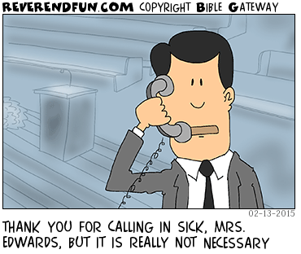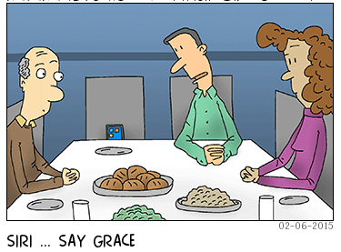

Rob Heverling
from the desk of

My words are inspired by last Sunday’s worship experience at the Highlands where the choreography of the singing, and prayers and different kinds of spoken messages refocused and elevated the command of Jesus to his disciples, “Go therefore and make disciples of all nations, baptizing them in the name of the Father and of the Son and of the Holy Spirit and teaching them to obey everything that I have commanded you. And remember, I am with you always, to the end of the age.”
Towards the end of my 33-year career in the broadcast news business, my company, E.W. Scripps, interviewed thousands of news consumers in cities across the United States to determine why our audiences were shrinking and why so many people were moving away from our local news platforms. To be interviewed, a person had to spend a minimum of one hour a day consuming news: TV News (watching or consuming online), reading a newspaper, listening to news radio, reading a news magazine, etc.
Some of the common themes that emerged from interviewing these hardcore news consumers:
- Local news had lost its way. No longer prioritizing remarkable, unbiased, in-depth journalism.
- We had become too political: serious news consumers valued strong journalism, balance in reporting with multiple points of view.

- Our stories were too short; they wanted long-form, in-depth reporting and more investigative content, holding the powerful accountable.
- We were too trivial, too silly at times, and put too much effort into entertaining our audience.
- Basically, hardcore news consumers claimed they didn’t consume our content as much anymore because our mission no longer stood out, we were trying too hard to appeal to a very broad audience, and we had ‘lost our salt’.
I have seen some parallels in the mission of the church, not just Community of Christ, but many churches. Sometimes I think ideology has been elevated above theology, elevated above the gospel.
As a news director, after that huge news consumer research project, I became much more focused on our core mission of producing remarkable journalism. We stopped doing a lot of what we thought would appeal to a large younger audience. We reinvested in our priority mission of journalism. And after a few years, our news costuming audience had grown. More serious news consumers of all ages were consuming my TV station’s news content.
This way of thinking is influencing how I lead in Community of Christ.
For example, even in our intensely polarized society, my political ideology is not the top priority in my Faith journey.
Leaning into the Gospel of Christ and trying (and failing) to live out the Sermon on the Mount has to be my priority.
I will not allow a political point of view to dominate my persona.
In Acts 1, even though the disciples had been exposed to all of Jesus' teachings, just before He ascended, it’s apparent their tunnel vision remains when they press Him for an earthly, political kingdom.
6 …“Lord, are you at this time [finally!] going to restore the kingdom to Israel?”
But for all intents and purposes, Jesus responds to their priority and says his priority for them is to preach the gospel, convert people, and grow the number of disciples in the world. He is more explicit in Matthew about this Great Commission.
The early church was up against an even more hostile and polarized culture than what we currently experience in the United States. But Christianity and the gospel message were brand new then. Perhaps after more than a couple of thousand years and a comparatively pretty easy life, that message no longer enthralls us. Perhaps for the Community of Christ, evangelism has been swept aside in our own politically charged culture with more relevant, more passionate, dare I say more meaningful priorities. Don’t misunderstand me. I support social justice. I am looking forward to working our booth at the 2026 KC PrideFest, reinforcing our Welcoming and Inclusive mission. With enthusiasm, I will attend the church’s 2026 Peace Forum, which focuses on critical environmental issues affecting our planet. I uplift our Central Avenue of Hope, confronting poverty in our community every day. But I am mindful that many organizations share these priorities. Be mindful not to dilute the church's core mission.
My top priority is sharing the Good News of Jesus Christ and showing others how leaning into the Gospel, learning the ways of the Holy Spirit, even in our suffering, is the most sustaining force there is.
Social justice is important, but I caution elevating it to the top of our Faith movement where we are united in a gospel translated into social policy.

