
Bethel Congregation
Midlands Mission Center
Welcoming the online community
Kansas City, KS
September 6, 2026 10:30AM CDT
What Do We Owe Each Other? (Brave Inquiry)
Presiding Priest Sandra Billings
Prelude and Welcome
Gathering Hymn “All Creatures of Our God and King” CCS #98
Announcements
Call to Worship
repeat the phrase, “Praise the Lord!” whenever the reader pauses
Leader: Sing to the Lord a new song, let Israel be glad in its
Maker; let us, the children of Zion, rejoice in our King!
All: Praise the Lord!
Leader: Let us praise the Lord with dancing and the music of
tambourine and lyre.
All: Praise the Lord!
Leader: Let the faithful exult in glory, let us sing for joy!
All: Praise the Lord!
*Opening Hymn “Holy, Holy, Holy! Lord God Almighty” CCS #52
*Invocation Grace Troeh
*Response
Prayer for Peace see insert Jordan Joyce
Focus Moment see insert
Hymn “Take the Path of the Disciple” CCS #558
Communion Message Elder Lynda Lyons
Invitation to Communion
All are welcome at Christ’s table. The Lord’s Supper, or Communion, is a sacrament in which we remember the life, death, resurrection, and continuing presence of Jesus Christ. In Community of Christ, we also experience Communion as an opportunity to renew our baptismal covenant and to be formed as disciples who live Christ’s mission. Others might have different or added understandings within their faith traditions. We invite all who participate in the Lord’s Supper to do so in the love and peace of Jesus Christ.
**Blessing and Serving of the Bread and Wine
Disciples’ Generous Response https://bit.ly/BethelGifts
Statement
The church’s mission statement states: “We proclaim Jesus Christ and promote communities of joy, hope, love, and peace.” One way we do that is by promoting Christ-centered communities of justice and peacefulness. Loving our neighbors is a commitment to valuing the worth of each person and generously meeting their needs.
Confession Prayer
Lord, we are thankful for our many blessings. We have been given the gift of love, acceptance, and sharing in our lives. We confess there are times when we do not share the wealth you have freely given us with those who need it most. We know your voice is calling, yet we do not listen. Give us the courage and strength to hear you, and to find ways to share your love and peace with others. Help us give freely of our finances, time, or loving support. We come today with a willingness to serve and follow you, as you are the way, the truth, and the life. Amen.
*Hymn of Neighbors “Help Us Accept Each Other” CCS #333
*Closing Prayer Andrew Miller
*Congregation invited to stand
**Congregation invited to kneel
Bethel Community of Christ bethel.forthrightsystems.com
Pastor Rob de Zwart
Financial Officer Jeff Cady
Media Host David Troeh
CCS: Community of Christ Sings, ©2013, Herald Publishing House
NRSVue: New Revised Standard Version updated edition, ©2021 Nat’l Council of Churches of Christ. Used by permission. All rights reserved.
Permission to podcast/stream the music and text in this
service obtained from One License with license A-727171.
Announcements
- Sunday 9/6 9:45 am Lectionary Disc: Romans 13:8-14
10:30 am What Do We Owe Each Other?
Elder Lynda Lyons speaking
Hybrid Communion Service
- Thursday 9/10 2:00 pm Women’s Meeting at Kris’ home
- Sunday 9/13 9:45 am Lectionary Disc: Matt. 18:21-35
10:30 am How Often Should We Forgive?
Elder Rob de Zwart speaking
- Sunday 9/20 Business Meeting – Gas Service line
- Our website, including weekly bulletin, web and zoom links: bethel.forthrightsystems.com
- Give through eTithing (https://www.cofchrist.org/give)
Optionally, search for Bethel, KS (or use link)

Recordings
All Creatures of Our God and King - CCS 98 - The Beyond the Walls Choir https://youtube.com/watch?v=ERE29Sgzvic
CCS 52 Holy, Holy, Holy! Lord God Almighty! https://youtube.com/watch?v=ey9OO2p7Y70
Take the Path of the Disciple - CCS 558 - The Beyond the Walls Choir https://youtube.com/watch?v=RXOFMidJ5Lg
As the Wind Song through the Trees - CCS 42 - The Beyond the Walls Choir https://youtube.com/watch?v=dXcn6brw7dg
CCS 333 Help Us Accept Each Other https://youtube.com/watch?v=YingJmN1YWQ
Lectionary
3-year cycle engaging significant portions of our Scripture.
This Week Sept 6 What Do We Owe Each Other?
Romans 13:8-14 Exodus 12:1-14
Psalm 149 Matthew 18:15-20
Next Week Sept 13 How Often Should We Forgive?
Matthew 18:21-35 Exodus 14:19-31
Psalm 114 Romans 14:1-12
Prayer for Peace

Scripture Setting:

Alma taught that everyone should love their neighbors as themselves; that there should be no contention among them. King Mosiah sent a proclamation throughout the land that there should be equality among all; that they should not let pride or haughtiness disturb their peace; that everyone should esteem their neighbor, laboring with their own hands for their support; doing the things that abound in the grace of God. And there began to be peace in the land…

Prayer

Dear Heavenly Parent,

Soften our hearts as we listen each day.

Give us the guidance to follow your ways.

Help our love grow with each new soul we meet.

Heal us with grace so we can bring peace.

In your living name, Amen.

Focus Moment

Close your eyes, take a few deep breaths. Imagine it is a beautiful day as you stand outside your home. Look to the left and the right and notice the houses there. Start walking, whichever way you want to go. If you know your neighbors, smile and greet them. If you don’t know your neighbors, smile and greet them, too. Throw a stick for a dog. Smile at the kids. Wave at the people sitting on their front porch. As you are walking, ask God to bless this community that is your neighborhood. Walk back home, noticing any difference you feel about your neighborhood.

Did you hear God’s whisper or nudge as you walked? Turn to another and share your experience.



THIS IS THE WAY

Please join us for our annual fall conference!

Topeka Congregation – 5252 SW 19th St
We welcome individuals from across the mission center to gather for worship, fellowship, sharing, and planning alongside Mission Center President Rob Heverling and “soon to be” Senior President of Seventy Larry McGuire.
Sunday, November 1
Schedule
10:45 am Song Service
11:00 am Worship
12:00 pm Lunch
1:30 – 3:30 pm Business Meeting



Online Ministry & Priesthood Classes
Center for Innovation in Ministry and Mission (CIMM)

To enroll or for more information on these classes and the certificate programs, visit graceland.edu/CIMM. Cost is $25 unless noted.

October 19 – December 13

- Introduction to Scripture – David Lloyd
- Ministry of Deacon – David Lloyd
- CYW Core

CIMM Sessions
CIMM Sessions are short seminars on topics of theology, culture, and Community of Christ Identity, Mission, Message, Beliefs and practices. Broadcast live and free on Zoom at 7:00pm most Wednesdays.
Register at graceland.edu/cimmsessions.

- Sept 2 – Community of Christ Sacraments — President Bunda Chibwe
- Sept 9 – God and Sex — Apostle Matt Frizzell
- Sept 16 & 23 – The Book of Mormon as Scripture: Then and Now (2-part series) — Historian Mark Scherer
- Sept 30 – International Resource Summit — Katie Harmon McLaughlin



7615 Platte Purchase Dr, Suite 116 presidentteam@midlandsmc.org
Kansas City, MO 64118 www.midlandsmc.org

JPAT Book Study

7pm Tuesdays 9/22, 10/6, 10/20, 11/10*

Join us as we explore Healing the Heart of Democracy by Parker Palmer. As the tension of living in a divided nation grows, finding common ground becomes more difficult each day. Palmer uses our hearts as a guide to reconcile and restore our democracy of freedom and responsibility. Registration is at bit.ly/JPAT-BS26. *Please note date change in November to avoid election day.

International Peace Forum

Seeds of Peace: Environmental Justice and Action

October 16 – 18

The event builds on the tradition of the International Peace Colloquy, offering worship, learning, and community engagement. All are welcome! Registration is now open! cofchrist.org/peace-forum

Racial Justice Summit

12 – 5:30 pm Saturday, November 7

The event sponsored by KC Disciples Becoming Beloved Community features Rev. Dr. Hanna R. Broome. It will be held at Intersect KC in KCMO. Register at KCDisciples.org/racial-justice.
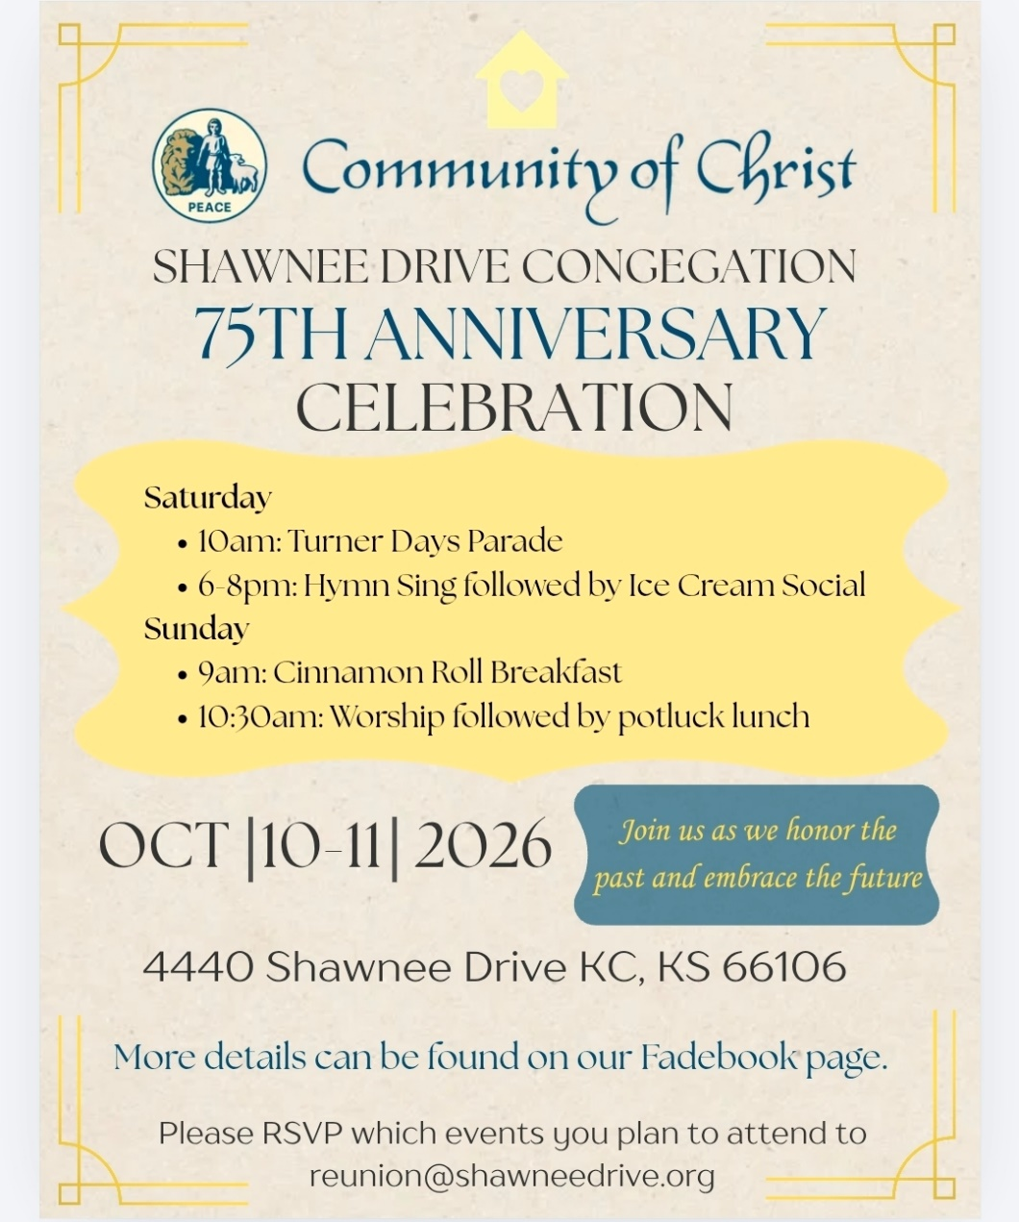

- 6pm Sundays YAM (Young Adult Ministry) online – contact Mikki Phillippe at mphilippe@cofchrist.org.
- 6pm Sunday, September 27 – Youth EMERGE online gathering – contact Humberto Tinsman htinsman@cofchrist.org
- Bi-monthly online Young Adult Coffee Talk – contact Humberto Tinsman htinsman@cofchrist.org for information and the link.

Rob Heverling
from the desk of

The Diary of a CEO is a podcast with an immense worldwide audience. It’s hosted by Steven Bartlett. He interviews leaders from all kinds of businesses, industries, non-profits, scientists, educators, doctors, and other kinds of experts.
Recently, Bartlett interviewed John Lennox, a mathematician, bioethicist, and Christian apologist.
During the interview, Bartlett said to Lennox, “You have a certain contentment that I rarely see in people that I interview… but I've almost always seen it in the Christians that I've interviewed. You have an anchoring that so many of us are looking for… You have a certain peace.”
I sure hope you can relate to this anchoring, to this certain contentment and peace that 34-year-old Steven Bartlett witnessed in 82-year-old John Lennox. And I think Bartlett understood age wasn’t necessarily the critical factor. It was the faith in God of this brilliant, humble mathematician.
It made me think of people in the Community of Christ who had a powerful influence on my Faith Journey as a boy, as a teenager, as a young adult. Women and Men who changed me. To name some of those old-school influencers: Ann and Jeff Heverling (my parents), Fay Elder, Glenda McClain, A.D. McClain, Mary Ann Parks, Don Sturgis, Chuck Cornman, Dorothy Magneson, Eldred Spain, Everett Graffeo.

There was, and still is, a holiness about these individuals. Not holy in a moralistic way, but holy in a way that they relentlessly tried to set themselves apart as disciples of Jesus.
I know they each had painful low points in their lives; yet all these people demonstrated an ‘anchoring’ and conveyed a deep sense of peace. They were my Jetti to emulate. They understood the ways of the Force (Holy Spirit).
Think about those people who dramatically influenced your Faith Journey.
I am often confronted with people… smart people, gifted people, who are adrift. Sometimes they are leaning too hard into their own understanding. They need an anchor. They need a source of peace. They need to learn the ways of the Holy Spirit.
Let this be our obligation and opportunity. To be in relationship with new acquaintances who become captivated by our anchoring, by our humility, by our Love, and by our capacity to be at peace.
Many will want what we have. We can teach them how a Faith Journey changes everything.
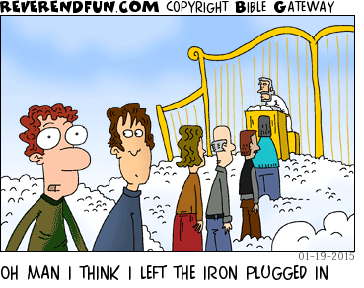
Shalom. Shalom, Rob

