
Bethel Congregation
Midlands Mission Center
Welcoming the online community
Kansas City, KS
September 13, 2026 10:30AM CDT
How Often Should We Forgive?
Presiding Elder Grace Troeh
Gathering Hymn “As We Gather” CCS #73
Announcements
Call to Worship Romans 14:7-9
⁷ We do not live to ourselves, and we do not die to ourselves. ⁸ If we live, we live to the Lord, and if we die, we die to the Lord; so then, whether we live or whether we die, we are the Lord’s. ⁹ For to this end Christ died and lived again, so that he might be Lord of both the dead and the living.
*Opening Hymn “Forgive Our Sins as We Forgive” CCS #215
*Invocation Kalene West
*Response
Focus Moment Growing in Love Stan Troeh
Hymn “Strong, Gentle Children” CCS #233
Prayer for Peace

God of Creation, Teach us your peace.

May we always remember we are the keepers of our behavior, and take responsibility for our own behavior, rather than blaming others.

Teach us to be willing to forgive others for the frictions which happen in our lives together. And may we remember your promise of forgiveness when we are not at our best.

Save us from the temptation to divide those we know into those on our side and those against us. And help us not to respond in kind when others choose conflict.

Teach us to listen to others – not just to reply, but to listen deeply, so we may understand them, for You have given us all the opportunity to learn from our lives, and we may learn from their lives’ experiences.

May we remember always the example Jesus gave us as he walked with the people who surrounded him.

Teach us to walk his path of peace, O God, we pray,

Amen
Sermon Elder Rob de Zwart
Offertory Hymn “When the World Is Babbling Round Us” #217
Disciples’ Generous Response https://bit.ly/BethelGifts
*Closing Hymn “The Love of God” CCS #210
*Closing Prayer
*Response
*Congregation invited to stand

Bethel Community of Christ bethel.forthrightsystems.com
Pastor Rob de Zwart
Financial Officer Jeff Cady
Media Host David Troeh
CCS: Community of Christ Sings, ©2013, Herald Publishing House
NRSVue: New Revised Standard Version updated edition, ©2021 Nat’l Council of Churches of Christ. Used by permission. All rights reserved.
Permission to podcast/stream the music and text in this
service obtained from One License with license A-727171.
Announcements
- Sunday 9/13 9:45 am Lectionary Disc: Matt. 18:21-35
10:30 am How Often Should We Forgive?
Elder Rob de Zwart speaking
Building Committee meeting after service
- Tuesday 9/15 7:00 pm Together Tuesday (924 6108 0153)
- Sunday 9/20 10:00 am BUSINESS MTG—gas line
10:30 am What Happens to Our Faith?
Camp Reflections
- Sunday 11/1 10:45 am Song Service & Communion
in Topeka 1:30 pm Mission Center Conference
both available via zoom as well as in-person
Invitation Video https://bethel.forthrightsystems.com/2026_MMC_Conf_Announcement.mov
- Our website, including weekly bulletin, web and zoom links: bethel.forthrightsystems.com
- Give through eTithing (https://www.cofchrist.org/give)
Optionally, search for Bethel, KS (or use link)

Recordings
CCS 73 - As We Gather - Music, Lyrics, Vocals, Video https://youtube.com/watch?v=bIFChkKhr9k

Lectionary
3-year cycle engaging significant portions of our Scripture.
This Week Sept 13 How Often Should We Forgive?
Matthew 18:21-35 Exodus 14:19-31
Psalm 114 Romans 14:1-12
Next Week Sept 20 What Happens to Our faith?
Exodus 16:2-15 Psalm 105:1-6, 37-45
Matthew 20:1-16 Philippians 1:21-30



THIS IS THE WAY

Please join us for our annual fall conference!

Topeka Congregation – 5252 SW 19th St
We welcome individuals from across the mission center to gather for worship, fellowship, sharing, and planning alongside Mission Center President Rob Heverling and “soon to be” Senior President of Seventy Larry McGuire.
Sunday, November 1
Schedule
10:45 am Song Service
11:00 am Worship
12:00 pm Lunch
1:30 – 3:30 pm Business Meeting



Online Ministry & Priesthood Classes
Center for Innovation in Ministry and Mission (CIMM)

To enroll or for more information on these classes and the certificate programs, visit graceland.edu/CIMM. Cost is $25 unless noted.

October 19 – December 13

- Introduction to Scripture – David Lloyd
- Ministry of Deacon – David Lloyd
- CYW Core

CIMM Sessions
CIMM Sessions are short seminars on topics of theology, culture, and Community of Christ Identity, Mission, Message, Beliefs and practices. Broadcast live and free on Zoom at 7:00pm most Wednesdays.
Register at graceland.edu/cimmsessions.

- Sept 2 – Community of Christ Sacraments — President Bunda Chibwe
- Sept 9 – God and Sex — Apostle Matt Frizzell
- Sept 16 & 23 – The Book of Mormon as Scripture: Then and Now (2-part series) — Historian Mark Scherer
- Sept 30 – International Resource Summit — Katie Harmon McLaughlin



7615 Platte Purchase Dr, Suite 116 presidentteam@midlandsmc.org
Kansas City, MO 64118 www.midlandsmc.org

JPAT Book Study

7pm Tuesdays 9/22, 10/6, 10/20, 11/10*

Join us as we explore Healing the Heart of Democracy by Parker Palmer. As the tension of living in a divided nation grows, finding common ground becomes more difficult each day. Palmer uses our hearts as a guide to reconcile and restore our democracy of freedom and responsibility. Registration is at bit.ly/JPAT-BS26. *Please note date change in November to avoid election day.

International Peace Forum

Seeds of Peace: Environmental Justice and Action

October 16 – 18

The event builds on the tradition of the International Peace Colloquy, offering worship, learning, and community engagement. All are welcome! Registration is now open! cofchrist.org/peace-forum

Racial Justice Summit

12 – 5:30 pm Saturday, November 7

The event sponsored by KC Disciples Becoming Beloved Community features Rev. Dr. Hanna R. Broome. It will be held at Intersect KC in KCMO. Register at KCDisciples.org/racial-justice.
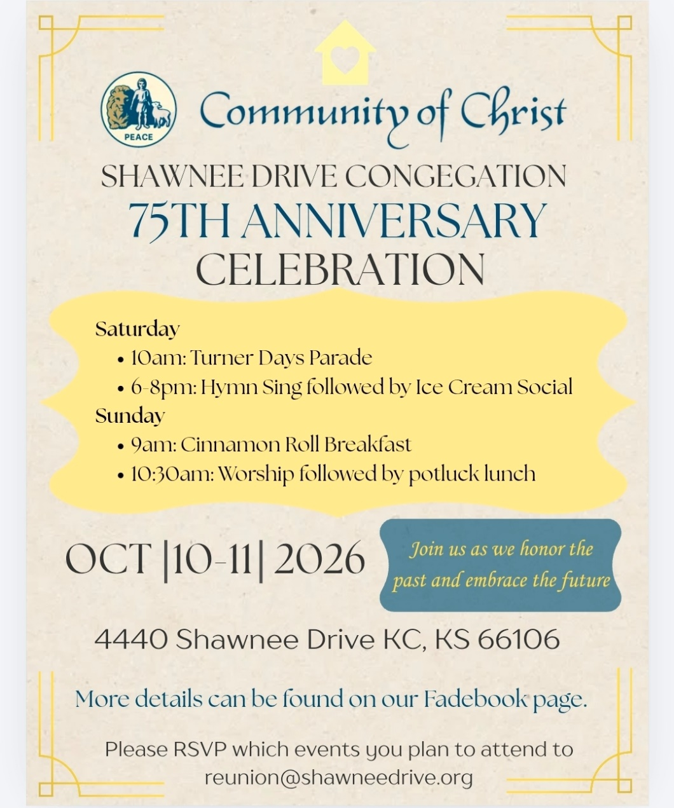

- 6pm Sundays YAM (Young Adult Ministry) online – contact Mikki Phillippe at mphilippe@cofchrist.org.
- 6pm Sunday, September 27 – Youth EMERGE online gathering – contact Humberto Tinsman htinsman@cofchrist.org
- Bi-monthly online Young Adult Coffee Talk – contact Humberto Tinsman htinsman@cofchrist.org for information and the link.

Rob Heverling
from the desk of

The Diary of a CEO is a podcast with an immense worldwide audience. It’s hosted by Steven Bartlett. He interviews leaders from all kinds of businesses, industries, non-profits, scientists, educators, doctors, and other kinds of experts.
Recently, Bartlett interviewed John Lennox, a mathematician, bioethicist, and Christian apologist.
During the interview, Bartlett said to Lennox, “You have a certain contentment that I rarely see in people that I interview… but I've almost always seen it in the Christians that I've interviewed. You have an anchoring that so many of us are looking for… You have a certain peace.”
I sure hope you can relate to this anchoring, to this certain contentment and peace that 34-year-old Steven Bartlett witnessed in 82-year-old John Lennox. And I think Bartlett understood age wasn’t necessarily the critical factor. It was the faith in God of this brilliant, humble mathematician.
It made me think of people in the Community of Christ who had a powerful influence on my Faith Journey as a boy, as a teenager, as a young adult. Women and Men who changed me. To name some of those old-school influencers: Ann and Jeff Heverling (my parents), Fay Elder, Glenda McClain, A.D. McClain, Mary Ann Parks, Don Sturgis, Chuck Cornman, Dorothy Magneson, Eldred Spain, Everett Graffeo.

There was, and still is, a holiness about these individuals. Not holy in a moralistic way, but holy in a way that they relentlessly tried to set themselves apart as disciples of Jesus.
I know they each had painful low points in their lives; yet all these people demonstrated an ‘anchoring’ and conveyed a deep sense of peace. They were my Jetti to emulate. They understood the ways of the Force (Holy Spirit).
Think about those people who dramatically influenced your Faith Journey.
I am often confronted with people… smart people, gifted people, who are adrift. Sometimes they are leaning too hard into their own understanding. They need an anchor. They need a source of peace. They need to learn the ways of the Holy Spirit.
Let this be our obligation and opportunity. To be in relationship with new acquaintances who become captivated by our anchoring, by our humility, by our Love, and by our capacity to be at peace.
Many will want what we have. We can teach them how a Faith Journey changes everything.
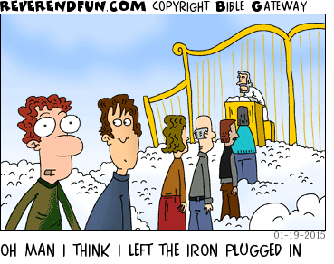
Shalom. Shalom, Rob

