
Bethel Congregation
Midlands Mission Center
Welcoming the online community
Kansas City, KS
September 20, 2026 10:30AM CDT
What Happens to Our Faith?
Heritage Day
Presiding Elder Kristine Shipley
Gathering Hymn “Bring Many Names” CCS #5
Welcome
Announcements
Invitation to Worship D&C 161:5, 162:2, 163:1,8c adapted
Leader: Be respectful of tradition…listen attentively to the telling of the sacred story,
People: for our story of scripture and faith empowers and illuminates.
Leader: Listen carefully to your own journey as a people,
People: for it is a sacred journey.
Leader: Community of Christ, your name, given as a divine blessing,
People: is our identity and calling.
Leader: Discover your future,
People: we will become a blessing to the whole creation.
Leader: The Temple calls the entire church
People: to become a sanctuary of Christ’s peace.
*Hymn “There’s an Old, Old Path” CCS #244
*Invocation
*Response
Prayer for Peace see insert
Focus Moment Jordan Joyce
Hymn “For Everyone Born” CCS #285
Camp Reflections
- Lake Doniphan Family Camp
- Junior and Middle School Camp
- Chihowa Family Camp
- Spectacular
- Camp MITIOG
- Youth Quest
Hymn “Great Is Thy Faithfulness” CCS #11
Disciples’ Generous Response https://bit.ly/BethelGifts
*Hymn “The Spirit of God Like a Fire Is Burning” CCS #384
*Benediction
Kaylee: Living God, we pray that we will be aware of your Spirit pouring out upon all people at every time in history, and through every generation.
Lorelei: Help us to imagine your future!
Jordan: Awaken in us your vision for the world as it can be!
Kyle: Dream within us your dream of peace and wholeness for every person at every stage of life as we respond to your unfolding mission throughout time.
All: Amen
*Response
*Congregation invited to stand

Bethel Community of Christ bethel.forthrightsystems.com
Pastor Rob de Zwart
Financial Officer Jeff Cady
Media Host David Troeh
Keyboards John Mueller
CCS: Community of Christ Sings, ©2013, Herald Publishing House
NRSVue: New Revised Standard Version updated edition, ©2021 Nat’l Council of Churches of Christ. Used by permission. All rights reserved.
Permission to podcast/stream the music and text in this
service obtained from One License with license A-727171.
Announcements
- Sunday 9/20 10:00 am BUSINESS MTG—gas line
10:30 am What Happens to Our Faith?
Camp Reflections
- Monday 9/21 7:00 pm Priesthood Meeting (949 9683 2354)
- Sunday 9/27 9:45 am Lectionary Disc.— Exodus 17:1-7
10:30 am Is the Lord among Us or Not?
High Priest Stan Troeh speaking
- Sunday 11/1 10:45 am Song Service & Communion
in Topeka 1:30 pm Mission Center Conference
both available via zoom as well as in-person
Invitation Video https://bethel.forthrightsystems.com/2026_MMC_Conf_Announcement.mov
- Our website, including weekly bulletin, web and zoom links: bethel.forthrightsystems.com
- Give through eTithing (https://www.cofchrist.org/give)
Optionally, search for Bethel, KS (or use link)
Recordings
Bring Many Names - CCS 5 - The Beyond the Walls Choir https://youtube.com/watch?v=-c0xEQ8-OcU
There’s an Old, Old Path - CCS 244 - The Beyond the Walls Choir (2024) https://youtube.com/watch?v=aoUNZJz7xZk
For Everyone Born - CCS 285 - The Beyond the Walls Choir (2024) https://youtube.com/watch?v=cdOvOXEiss0
The Spirit of God like a Fire Is Burning - CCS 384 - The Beyond the Walls Choir (2020) https://youtube.com/watch?v=U1OATKKmpE0
Lectionary
3-year cycle engaging significant portions of our Scripture.
This Week Sept 20 What Happens to Our faith?
Exodus 16:2-15 Psalm 105:1-6, 37-45
Matthew 20:1-16 Philippians 1:21-30
Next Week Sept 27 Is the Lord among Us or Not?
Exodus 17:1-7 Psalm 78:1-4, 12-16
Matthew 21:23-32 Philippians 2:1-13
Prayer for Peace
Our hearts are broken by the events of our day. Wherever we look, we see violence—violence through hunger, abuse, economic policies, and war. Yet while we seem empathetic toward those who are suffering, we are not yet angry enough to work toward a solution.
Make us more aware that mere thoughts are insufficient to address the needs of the world in which we live. Help us to see that we all can be more involved in the activities of life—involved to the degree that we elect those government officials who will worry more about human dignity than reelection; involved to the degree that we will not give a minute’s rest to elected officials through aggressive action demanding their efforts toward solutions.
Restore our relationships, O God—our relationships with ourselves, our relationships with one another, and our relationship with you. For we acknowledge that it is only through right relationships that we will truly understand what is meant by peace. We recognize that peace is a lifestyle that must be continually nurtured. We affirm that such a lifestyle is what each of us wants. Grant that we may do so through your power and wisdom. Grant that we may become a people of peace for your glory, O God.
Bless us now as we seek to understand; as we work toward fulfilling your purpose in us; as we strive to live lives of wholeness and righteousness. In the name of God, the Creator; God, the Redeemer; and God, the loving Presence amid life. Amen. —Steven Shields

Business Meeting Resolution

WHEREAS, the current gas line has multiple leaks along the length, and

WHEREAS, the congregation leadership received three bids to replace the gas line, and

WHEREAS, the sanctuary air conditioners both required service in the amount of $1147, and

WHEREAS, the cost of completing all of this work would consume a significant portion of the congregation’s liquid and/or semi-liquid funding, and

WHEREAS, the building committee met and in a near-unanimous decision recommends accepting the Grabill bid to replace the gas line, and

WHEREAS, the building committee unanimously recommends seeking a World Church Houses of Worship loan to cover the costs of the gas line and air conditioning work; therefore, be it

RESOLVED, that the congregation accept the Grabill ($16,400) bid to replace the gas line, and be it further

RESOLVED, that the congregation seek a World Church Houses of Worship loan to cover the costs of replacing the gas line and repairing the sanctuary air conditioning.



THIS IS THE WAY

Please join us for our annual fall conference!

Topeka Congregation – 5252 SW 19th St
We welcome individuals from across the mission center to gather for worship, fellowship, sharing, and planning alongside Mission Center President Rob Heverling and “soon to be” Senior President of Seventy Larry McGuire.
Sunday, November 1
Schedule
10:45 am Song Service
11:00 am Worship
12:00 pm Lunch
1:30 – 3:30 pm Business Meeting



Online Ministry & Priesthood Classes
Center for Innovation in Ministry and Mission (CIMM)

To enroll or for more information on these classes and the certificate programs, visit graceland.edu/CIMM. Cost is $25 unless noted.

October 19 – December 13

- Introduction to Scripture – David Lloyd
- Ministry of Deacon – David Lloyd
- CYW Core

CIMM Sessions
CIMM Sessions are short seminars on topics of theology, culture, and Community of Christ Identity, Mission, Message, Beliefs and practices. Broadcast live and free on Zoom at 7:00pm most Wednesdays.
Register at graceland.edu/cimmsessions.

- Sept 2 – Community of Christ Sacraments — President Bunda Chibwe
- Sept 9 – God and Sex — Apostle Matt Frizzell
- Sept 16 & 23 – The Book of Mormon as Scripture: Then and Now (2-part series) — Historian Mark Scherer
- Sept 30 – International Resource Summit — Katie Harmon McLaughlin






7615 Platte Purchase Dr, Suite 116 presidentteam@midlandsmc.org
Kansas City, MO 64118 www.midlandsmc.org

JPAT Book Study

7pm Tuesdays 9/22, 10/6, 10/20, 11/10*

Join us as we explore Healing the Heart of Democracy by Parker Palmer. As the tension of living in a divided nation grows, finding common ground becomes more difficult each day. Palmer uses our hearts as a guide to reconcile and restore our democracy of freedom and responsibility. Registration is at bit.ly/JPAT-BS26. *Please note date change in November to avoid election day.

International Peace Forum

Seeds of Peace: Environmental Justice and Action

October 16 – 18

The event builds on the tradition of the International Peace Colloquy, offering worship, learning, and community engagement. All are welcome! Registration is now open! cofchrist.org/peace-forum

Racial Justice Summit

12 – 5:30 pm Saturday, November 7

The event sponsored by KC Disciples Becoming Beloved Community features Rev. Dr. Hanna R. Broome. It will be held at Intersect KC in KCMO. Register at KCDisciples.org/racial-justice.
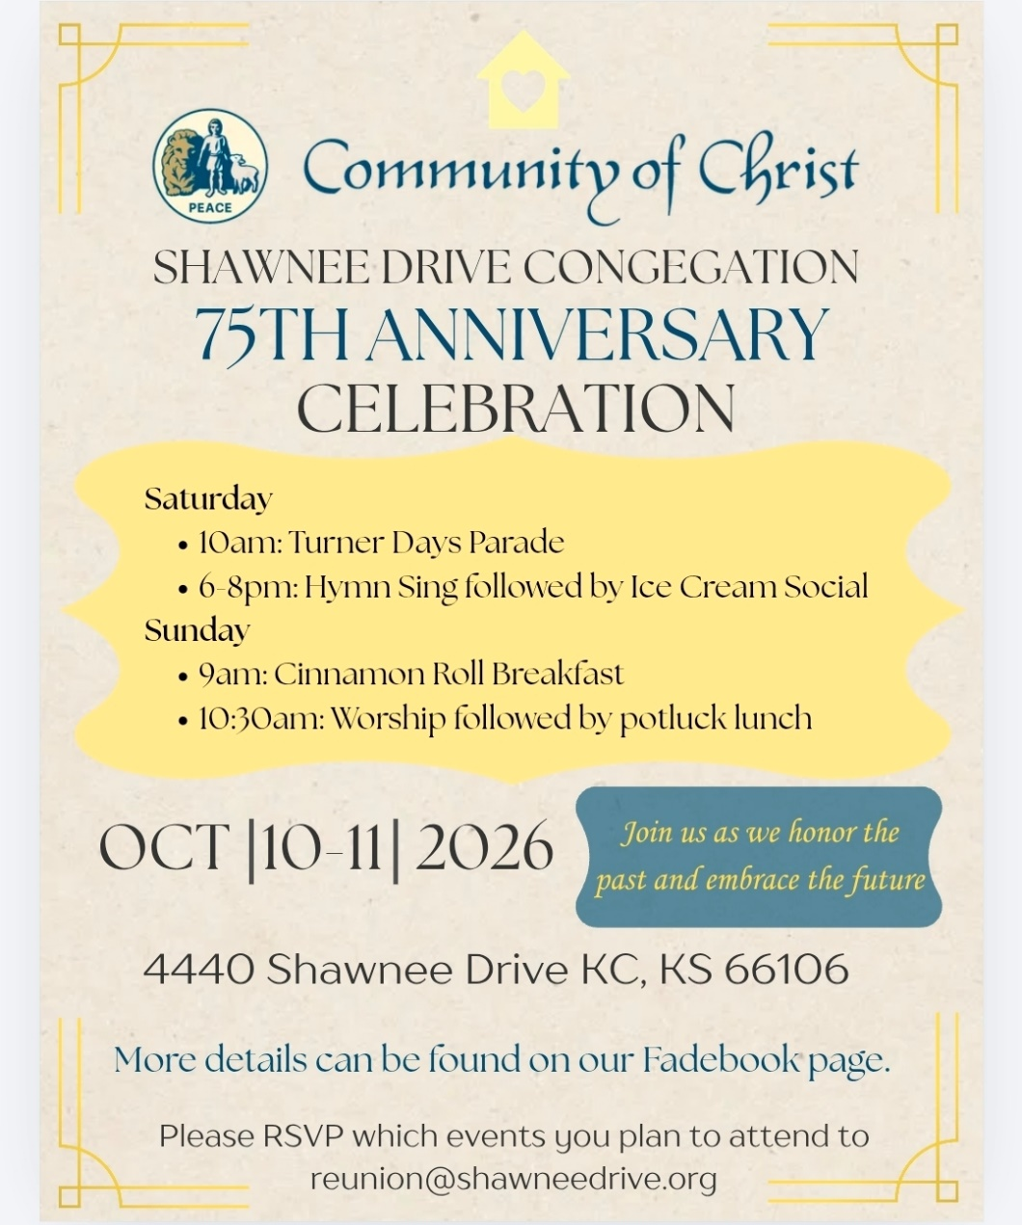

- 6pm Sundays YAM (Young Adult Ministry) online – contact Mikki Phillippe at mphilippe@cofchrist.org.
- 6pm Sunday, September 27 – Youth EMERGE online gathering – contact Humberto Tinsman htinsman@cofchrist.org
- Bi-monthly online Young Adult Coffee Talk – contact Humberto Tinsman htinsman@cofchrist.org for information and the link.

Rob Heverling
from the desk of

The Diary of a CEO is a podcast with an immense worldwide audience. It’s hosted by Steven Bartlett. He interviews leaders from all kinds of businesses, industries, non-profits, scientists, educators, doctors, and other kinds of experts.
Recently, Bartlett interviewed John Lennox, a mathematician, bioethicist, and Christian apologist.
During the interview, Bartlett said to Lennox, “You have a certain contentment that I rarely see in people that I interview… but I've almost always seen it in the Christians that I've interviewed. You have an anchoring that so many of us are looking for… You have a certain peace.”
I sure hope you can relate to this anchoring, to this certain contentment and peace that 34-year-old Steven Bartlett witnessed in 82-year-old John Lennox. And I think Bartlett understood age wasn’t necessarily the critical factor. It was the faith in God of this brilliant, humble mathematician.
It made me think of people in the Community of Christ who had a powerful influence on my Faith Journey as a boy, as a teenager, as a young adult. Women and Men who changed me. To name some of those old-school influencers: Ann and Jeff Heverling (my parents), Fay Elder, Glenda McClain, A.D. McClain, Mary Ann Parks, Don Sturgis, Chuck Cornman, Dorothy Magneson, Eldred Spain, Everett Graffeo.

There was, and still is, a holiness about these individuals. Not holy in a moralistic way, but holy in a way that they relentlessly tried to set themselves apart as disciples of Jesus.
I know they each had painful low points in their lives; yet all these people demonstrated an ‘anchoring’ and conveyed a deep sense of peace. They were my Jetti to emulate. They understood the ways of the Force (Holy Spirit).
Think about those people who dramatically influenced your Faith Journey.
I am often confronted with people… smart people, gifted people, who are adrift. Sometimes they are leaning too hard into their own understanding. They need an anchor. They need a source of peace. They need to learn the ways of the Holy Spirit.
Let this be our obligation and opportunity. To be in relationship with new acquaintances who become captivated by our anchoring, by our humility, by our Love, and by our capacity to be at peace.
Many will want what we have. We can teach them how a Faith Journey changes everything.
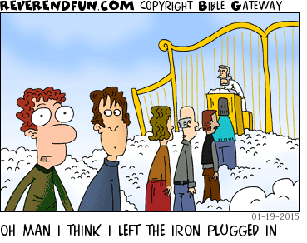
Shalom. Shalom, Rob

