
Bethel Congregation
Midlands Mission Center
Welcoming the online community
Kansas City, KS
September 27, 2026 10:30AM CDT
Is the Lord among Us or Not?

Presiding Teacher Ylva Hup
Announcements and Welcome
Gathering Hymn “Come Now, You Hungry” CCS #227
Call to Worship Exodus 17:1-7
Water from the Rock
17 From the wilderness of Sin the whole congregation of the Israelites journeyed by stages, as the Lord commanded. They camped at Rephidim, but there was no water for the people to drink. ² The people quarreled with Moses, and said, ‘Give us water to drink.’ Moses said to them, ‘Why do you quarrel with me? Why do you test the Lord?’ ³ But the people thirsted there for water; and the people complained against Moses and said, ‘Why did you bring us out of Egypt, to kill us and our children and livestock with thirst?’ ⁴ So Moses cried out to the Lord, ‘What shall I do with this people? They are almost ready to stone me.’ ⁵ The Lord said to Moses, ‘Go on ahead of the people, and take some of the elders of Israel with you; take in your hand the staff with which you struck the Nile, and go. ⁶ I will be standing there in front of you on the rock at Horeb. Strike the rock, and water will come out of it, so that the people may drink.’ Moses did so, in the sight of the elders of Israel. ⁷ He called the place Massah^{[a]} and Meribah,^{[b]} because the Israelites quarreled and tested the Lord, saying, ‘Is the Lord among us or not?’
*Invocation Ylva Hup
*Hymn “Gather Your Children” CCS #77
Prayer for Peace see insert Jonathan Gray
Disciples’ Generous Response https://bit.ly/BethelGifts Rob

World Church funding supports Community of Christ World Hunger programs. People all over the world receive blessings from these grants. Danielle, 14, of Haiti, says,

I love the food we get at school. We have rice, vegetables, and even meat! We never have meat at home. We cannot afford it. My parents are also pleased because they don’t have to spend so much money on food for me and my brother. Instead, they use that money to buy books for my education.

—2015 Annual Report, Community of Christ
“Keep Tithing! Or Get Started!” video
Music for Reflection “Rain Down” CCS #260
Spoken Word High Priest Stan Troeh
*Hymn “Praise the Lord Together Singing” CCS #642
*Benediction Susan Boer
*Sending Forth Doctrine and Covenants 164:9a Ylva Hup
Beloved children of the Restoration, your continuing faith adventure with God has been divinely led, eventful, challenging, and sometimes surprising to you. By the grace of God, you are poised to fulfill God’s ultimate vision for the church.
*Congregation invited to stand

Bethel Community of Christ bethel.forthrightsystems.com
Pastor Rob de Zwart
Financial Officer Jeff Cady
Media Host David Troeh
Keyboards John Mueller
CCS: Community of Christ Sings, ©2013, Herald Publishing House
NRSVue: New Revised Standard Version updated edition, ©2021 Nat’l Council of Churches of Christ. Used by permission. All rights reserved.
Permission to podcast/stream the music and text in this
service obtained from One License with license A-727171.
Announcements
- Sunday 9/27 9:45 am Lectionary Disc.— Exodus 17:1-7
10:30 am Is the Lord among Us or Not?
High Priest Stan Troeh speaking
- Tuesday 9/29 7:00 pm Together Tuesday (924 6108 0153)
- Sunday 10/4 9:45 am Lectionary Disc.— Exodus 20:1-21
10:30 am What Is God Revealing? (Invest)
Hybrid Communion Elder Rob de Zwart speaking
- Sunday 11/1 10:45 am Song Service & Communion
in Topeka 1:30 pm Mission Center Conference
both available via zoom as well as in-person
Invitation Video https://bethel.forthrightsystems.com/2026_MMC_Conf_Announcement.mov
- Our website, including weekly bulletin, web and zoom links: bethel.forthrightsystems.com
- Give through eTithing (https://www.cofchrist.org/give)
Optionally, search for Bethel, KS (or use link)
Recordings
Come Now, You Hungry - CCS 227 - The Beyond the Walls Choir https://youtube.com/watch?v=B4nAWuTbp_s
Gather Your Children - CCS 77 - The Beyond the Walls Choir (2021 Mix with Drums) https://youtube.com/watch?v=9d7spOHA9_
Rain Down (2021) - CCS 260 - The Beyond the Walls Choir https://youtube.com/watch?v=vPF3chvC_cI
CCS 642 - Praise the Lord Together Singing - Music Lyrics Voices and VIDEO https://youtube.com/watch?v=gaFhvp9Ve7k
Lectionary
3-year cycle engaging significant portions of our Scripture.
This Week Sept 27 Is the Lord among Us or Not?
Exodus 17:1-7 Psalm 78:1-4, 12-16
Matthew 21:23-32 Philippians 2:1-13
Next Week Oct 4 What Is God Revealing? (Invest)
Exodus 20:1-4, 7-9, 12-21 Psalm 19
Matthew 21:33-46 Philippians 3:4b-14
Prayer for Peace

Poem: Litter on the Labyrinth

Turning, I saw,

brittle on the path behind me,

benign and without power,

the same sticks and stones that

once hurt my feelings,

once made me doubt.

Now beautiful in their restored innocence,

reborn to the purpose of their creation—

scaffolding for the peaceable estate,

structure to shape the strata.

Atoning for corruption of use

as weapons of mass spiritual destruction—

sticks, once sharp and threatening,

now mere “kum-ba-ya” kindling,

fine bones for weaving nests.

Stones, once formidable and dense with guilt,

now rolled away from a self-imposed tomb,

exposing slices of forgiving light,

now mine to freely emit.

Bone-breaking stones will never again

lessen my resolve,

flatten my faith.

I see them for what they are….

inventions of my imagination,

detritus to trip me on my journey.

I leave behind

as litter on the labyrinth.

No dragging the burden with me,

obliterating the path,

scattering the bread-crumb trail home.

I will duck if I sense, once again,

sticks pointed,

stones hurled.

“Oh, was that an insult, a criticism, a slight?

I must have misunderstood!

Forgive me.” Amen



THIS IS THE WAY

Please join us for our annual fall conference!

Topeka Congregation – 5252 SW 19th St
We welcome individuals from across the mission center to gather for worship, fellowship, sharing, and planning alongside Mission Center President Rob Heverling and “soon to be” Senior President of Seventy Larry McGuire.
Sunday, November 1
Schedule
10:45 am Song Service
11:00 am Worship
12:00 pm Lunch
1:30 – 3:30 pm Business Meeting



Online Ministry & Priesthood Classes
Center for Innovation in Ministry and Mission (CIMM)

To enroll or for more information on these classes and the certificate programs, visit graceland.edu/CIMM. Cost is $25 unless noted.

October 19 – December 13

- Introduction to Scripture – David Lloyd
- Ministry of Deacon – David Lloyd
- CYW Core

CIMM Sessions
CIMM Sessions are short seminars on topics of theology, culture, and Community of Christ Identity, Mission, Message, Beliefs and practices. Broadcast live and free on Zoom at 7:00pm most Wednesdays.
Register at graceland.edu/cimmsessions.

- Sept 2 – Community of Christ Sacraments — President Bunda Chibwe
- Sept 9 – God and Sex — Apostle Matt Frizzell
- Sept 16 & 23 – The Book of Mormon as Scripture: Then and Now (2-part series) — Historian Mark Scherer
- Sept 30 – International Resource Summit — Katie Harmon McLaughlin






7615 Platte Purchase Dr, Suite 116 presidentteam@midlandsmc.org
Kansas City, MO 64118 www.midlandsmc.org

JPAT Book Study

7pm Tuesdays 9/22, 10/6, 10/20, 11/10*

Join us as we explore Healing the Heart of Democracy by Parker Palmer. As the tension of living in a divided nation grows, finding common ground becomes more difficult each day. Palmer uses our hearts as a guide to reconcile and restore our democracy of freedom and responsibility. Registration is at bit.ly/JPAT-BS26. *Please note date change in November to avoid election day.

International Peace Forum

Seeds of Peace: Environmental Justice and Action

October 16 – 18

The event builds on the tradition of the International Peace Colloquy, offering worship, learning, and community engagement. All are welcome! Registration is now open! cofchrist.org/peace-forum

Racial Justice Summit

12 – 5:30 pm Saturday, November 7

The event sponsored by KC Disciples Becoming Beloved Community features Rev. Dr. Hanna R. Broome. It will be held at Intersect KC in KCMO. Register at KCDisciples.org/racial-justice.
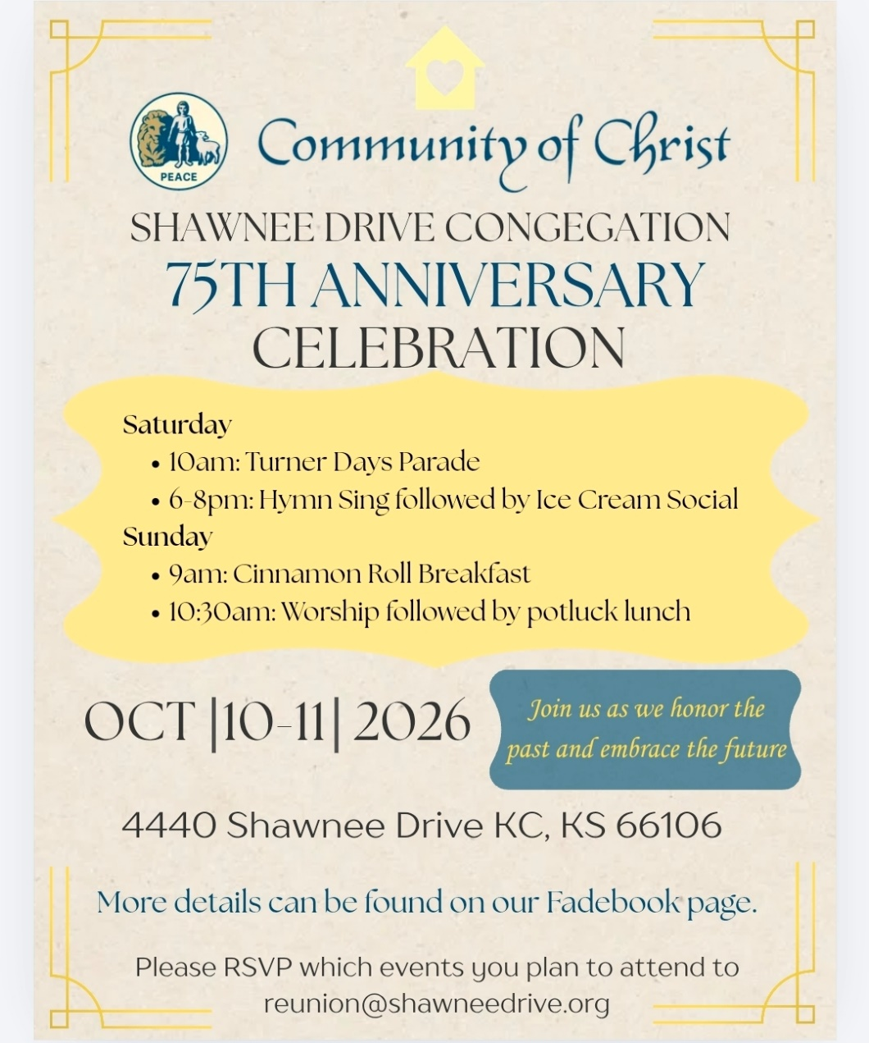

- 6pm Sundays YAM (Young Adult Ministry) online – contact Mikki Phillippe at mphilippe@cofchrist.org.
- 6pm Sunday, September 27 – Youth EMERGE online gathering – contact Humberto Tinsman htinsman@cofchrist.org
- Bi-monthly online Young Adult Coffee Talk – contact Humberto Tinsman htinsman@cofchrist.org for information and the link.

Rob Heverling
from the desk of

The Diary of a CEO is a podcast with an immense worldwide audience. It’s hosted by Steven Bartlett. He interviews leaders from all kinds of businesses, industries, non-profits, scientists, educators, doctors, and other kinds of experts.
Recently, Bartlett interviewed John Lennox, a mathematician, bioethicist, and Christian apologist.
During the interview, Bartlett said to Lennox, “You have a certain contentment that I rarely see in people that I interview… but I've almost always seen it in the Christians that I've interviewed. You have an anchoring that so many of us are looking for… You have a certain peace.”
I sure hope you can relate to this anchoring, to this certain contentment and peace that 34-year-old Steven Bartlett witnessed in 82-year-old John Lennox. And I think Bartlett understood age wasn’t necessarily the critical factor. It was the faith in God of this brilliant, humble mathematician.
It made me think of people in the Community of Christ who had a powerful influence on my Faith Journey as a boy, as a teenager, as a young adult. Women and Men who changed me. To name some of those old-school influencers: Ann and Jeff Heverling (my parents), Fay Elder, Glenda McClain, A.D. McClain, Mary Ann Parks, Don Sturgis, Chuck Cornman, Dorothy Magneson, Eldred Spain, Everett Graffeo.

There was, and still is, a holiness about these individuals. Not holy in a moralistic way, but holy in a way that they relentlessly tried to set themselves apart as disciples of Jesus.
I know they each had painful low points in their lives; yet all these people demonstrated an ‘anchoring’ and conveyed a deep sense of peace. They were my Jetti to emulate. They understood the ways of the Force (Holy Spirit).
Think about those people who dramatically influenced your Faith Journey.
I am often confronted with people… smart people, gifted people, who are adrift. Sometimes they are leaning too hard into their own understanding. They need an anchor. They need a source of peace. They need to learn the ways of the Holy Spirit.
Let this be our obligation and opportunity. To be in relationship with new acquaintances who become captivated by our anchoring, by our humility, by our Love, and by our capacity to be at peace.
Many will want what we have. We can teach them how a Faith Journey changes everything.
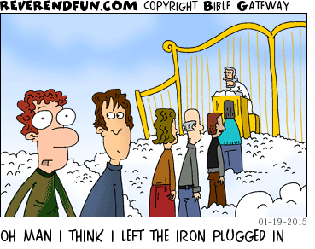
Shalom. Shalom, Rob

