
Bethel Congregation
Midlands Mission Center
Welcoming the online community
Kansas City, KS
October 4, 2026 10:30AM CDT
What Is God Revealing? (Invest)

Presiding Elder Kristine Shipley
Announcements
Welcome
Invitation to Worship Psalm 19:1,7-9,14
The heavens are telling the glory of God,
and the firmament[a] proclaims his handiwork.
The law of the Lord is perfect,
reviving the soul;
the decrees of the Lord are sure,
making wise the simple;
the precepts of the Lord are right,
rejoicing the heart;
the commandment of the Lord is clear,
enlightening the eyes;
the fear of the Lord is pure,
enduring forever;
the ordinances of the Lord are true
and righteous altogether.
Let the words of my mouth and the meditation of my heart
be acceptable to you,
O Lord, my rock and my redeemer.
*Hymn “Redeemer of Israel” CCS #388
*Invocation
*Response
Prayer for Peace see insert
Hymn “Teach Me, God, to Wonder” CCS #176
Communion Message Elder Rob de Zwart
Invitation to Communion
All are welcome at Christ’s table. The Lord’s Supper, or Communion, is a sacrament in which we remember the life, death, resurrection, and continuing presence of Jesus Christ. In Community of Christ, we also experience Communion as an opportunity to renew our baptismal covenant and to be formed as disciples who live Christ’s mission. Others may have different or added understandings within their faith traditions. We invite all who participate in the Lord’s Supper to do so in the love and peace of Jesus Christ.
Hymn “Coming Together for Wine and for Bread” CCS #516
**Blessing and Serving of the Bread and Wine
Disciples’ Generous Response https://bit.ly/BethelGifts
*Hymn “Send Me Forth” CCS #651
*Sending Forth Philippians 3:12-14
Not that I have already obtained this or have already reached the goal, but I press on to lay hold of that for which Christ has laid hold of me. Brothers and sisters, I do not consider that I have laid hold of it, but one thing I have laid hold of: forgetting what lies behind and straining forward to what lies ahead, I press on toward the goal, toward the prize of the heavenly call of God in Christ Jesus.
*Congregation invited to stand
**Congregation invited to kneel

Bethel Community of Christ bethel.forthrightsystems.com
Pastor Rob de Zwart
Financial Officer Jeff Cady
Media Host David Troeh
CCS: Community of Christ Sings, ©2013, Herald Publishing House
NRSVue: New Revised Standard Version updated edition, ©2021 Nat’l Council of Churches of Christ. Used by permission. All rights reserved.
Permission to podcast/stream the music and text in this
service obtained from One License with license A-727171.
Announcements
- Sunday 10/4 9:45 am Lectionary Disc.— Exodus 20:1-21
10:30 am What Is God Revealing? (Invest)
Hybrid Communion Elder Rob de Zwart speaking
- Thursday 10/8 2:00 pm Women’s Meeting
- Sunday 10/11 9:45 am Lectionary Disc.— Exodus 32:1-14
10:30 am Why Do We Turn Away?
Elder Aaron Laughlin speaking
- Sunday 11/1 10:45 am Song Service & Communion
in Topeka 1:30 pm Mission Center Conference
both available via zoom as well as in-person
Invitation Video https://bethel.forthrightsystems.com/2026_MMC_Conf_Announcement.mov
- Our website, including weekly bulletin, web and zoom links: bethel.forthrightsystems.com
- Give through eTithing (https://www.cofchrist.org/give)
Optionally, search for Bethel, KS (or use link)
Recordings
Redeemer of Israel - CCS 388 - The Beyond the Walls Choir (2024) https://youtu.be/-9CSUME1QW0
CCS 176 Teach Me God To Wonder https://youtu.be/xITMpqrtZ7I
Coming Together for Wine and for Bread - CCS 516 - The Beyond the Walls Choir https://youtu.be/jB8QLCbDhEM
Send Me Forth - CCS 651 - The Beyond the Walls Choir (2022) https://youtu.be/VJ3X8rf59AQ
Lectionary
3-year cycle engaging significant portions of our Scripture.
This Week Oct 4 What Is God Revealing? (Invest)
Exodus 20:1-4, 7-9, 12-21 Psalm 19
Matthew 21:33-46 Philippians 3:4b-14
Next Week Oct 11 Why Do We Turn Away?
Exodus 32:1-14 Psalm 106:1-6,19-23
Matthew 22:1-14 Philippians 4:1-9
Prayer for Peace
Silent God.
Sometimes we mistake your silence for absence, or we feel we have been ignored.
Instead, your silence is calling us to be silent and know you. In silence we hear you speak your message of peace. You move us from the measurement of life into living life.
The noise of conflict between people fills our world. It jars our nerves and confuses us with who is right. When we think we know what is right, we tend to turn the other into the enemy. Help us see the face of God in each one and recognize the worth of each person, even those with whom we disagree.
The noise of conflict between nations fills our world. Long and bitter disputes have resulted in the death and suffering of many. The resources of the world are wasted on armaments and wars while children and the poor continue to suffer. Help us be impatient for peace; help us demand that our leaders seek pathways of peace rather than reasons for war.
Lead us by the still, small voice into personal, community, and world peace. By your Spirit help us to be silent and know you. In the name of the Prince of Peace we pray.
Amen.



Online Ministry & Priesthood Classes
Center for Innovation in Ministry and Mission (CIMM)

To enroll or for more information on these classes and the certificate programs, visit graceland.edu/CIMM. Cost is $25 unless noted.

October 19 – December 13

- Introduction to Scripture – David Lloyd
- Ministry of Deacon – David Lloyd
- CYW Core
- CIMM Missional Leadership – Larry McGuire
- CIMM Discernment as Process: Preparing the Community and Entering the Process

CIMM Sessions
CIMM Sessions are short seminars on topics of theology, culture, and Community of Christ Identity, Mission, Message, Beliefs and practices. Broadcast live and free on Zoom at 7:00pm most Wednesdays.
Register at graceland.edu/cimmsessions.

- Oct 7 – Year B and Advent Materials — Tyler Marz
- Oct 14 – Israel/Palestine Pt 1 – What are the causes of the conflict? — Andrew Bolton with Steve Kellogg, Destiny Magnet, Steve Glazer
- Oct 21 – “It’s Never as Simple as We Think” — Brittany Mangelson
- Oct 28 – WCR 1324, Resolution on Baptism and Membership — President Stassi Cramm


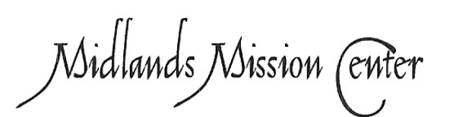
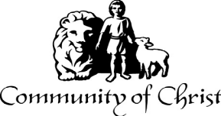

7615 Platte Purchase Dr, Suite 116 presidentteam@midlandsmc.org
Kansas City, MO 64118 www.midlandsmc.org

THIS IS THE WAY

Please join us for our annual fall conference!

Topeka Congregation – 5252 SW 19th St
We welcome individuals from across the mission center to gather for worship, fellowship, sharing, and planning alongside Mission Center President Rob Heverling and “soon to be” Senior President of Seventy Larry McGuire.
Sunday, November 1
Schedule
10:45 am Song Service
11:00 am Worship
12:00 pm Lunch
1:30 – 3:30 pm Business Meeting



JPAT Book Study
7pm Tuesdays 9/22, 10/6, 10/20, 11/10*

Join us as we explore Healing the Heart of Democracy by Parker Palmer. As the tension of living in a divided nation grows, finding common ground becomes more difficult each day. Palmer uses our hearts as a guide to reconcile and restore our democracy of freedom and responsibility. Registration is at bit.ly/JPAT-BS26. *Please note date change in November to avoid election day.

International Peace Forum

Seeds of Peace: Environmental Justice and Action

October 16 – 18

The event builds on the tradition of the International Peace Colloquy, offering worship, learning, and community engagement. All are welcome! Registration is now open! cofchrist.org/peace-forum

Racial Justice Summit

12 – 5:30 pm Saturday, November 7

The event sponsored by KC Disciples Becoming Beloved Community features Rev. Dr. Hanna R. Broome. It will be held at Intersect KC in KCMO. Register at KCDisciples.org/racial-justice.

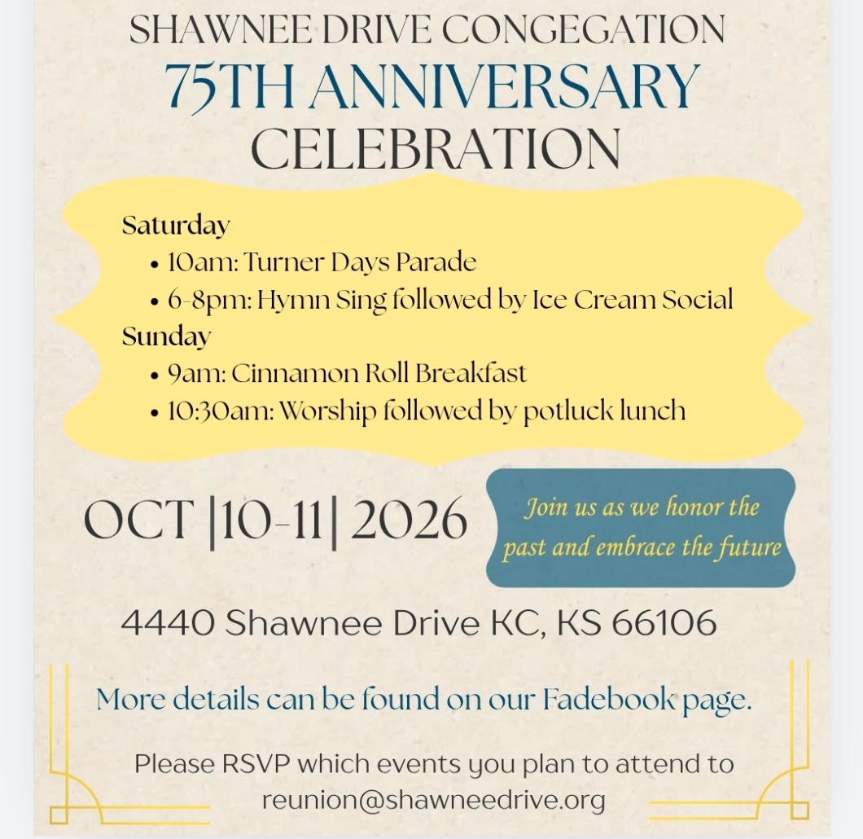

Youth & Young Adults
- 6pm Sat, Oct 10 @ Olathe – Young Adult Escape Room (bring a snack)
- 12pm Oct 24 @ The Highlands – Young adults make blankets to donate, watch Halloween movies, and eat pizza!
- Oct 24 @ Olathe – Youth Trunk or Treat, dinner, and activities
- 6pm Sundays YAM (Young Adult Ministry) online*
- 6pm Sunday, Oct 25 – Youth EMERGE online* gathering
- Bi-monthly online* Young Adult Coffee Talk

*For information, contact Humberto Tinsman htinsman@cofchrist.org

from the desk of
Rob Heverling

Recently, I have felt the weight of the legacies of all the congregations in the Midlands Mission Center. Over the past couple of weeks, I've had individual Zoom conversations with mission center pastors, and some financial officers have joined too. Every congregation has made a remarkable impact on its community, with countless examples of Spirit-led discipleship changing lives.
I learned a lot in the hour I spent listening to our congregations' leaders. I was struck by the unique Spiritual Gifts each congregation's members have displayed and deployed over the decades. And those Spiritual Gifts are still being humbly and powerfully wielded today.
It’s like I’ve been talking to a bunch of Jedi Knights who know the ways of the Force.
1st Corinthians 12: 4-7
4 Now there are varieties of gifts but the same Spirit, 5 and there are varieties of services but the same Lord, 6 and there are varieties of activities, but it is the same God who activates all of them in everyone. 7 To each is given the manifestation of the Spirit for the common good.
Here in the Midlands MC, I have been inspired by experienced and gifted people who have relentlessly worked to put Christ at the center of their lives and expressed Christlike love to so many people.
You all have reinforced what I believe… And that is, you are not even capable of wanting Jesus in the center of your life except by the Holy Spirit present in your life.
I’m enthralled by the matrix of Spiritual Gifts in the members of Community of Christ in our mission center. And the use of these gifts in the service of others, I feel, is more unique to our movement than other Faith traditions.
Our Spiritual Gifts are not necessarily inherent in us. We do not deserve these gifts. These are clusters of gifts bestowed on members of the Community of Christ to meet the needs of others.
And there are still many needs. This is why I have hope. This is why I believe there will be pockets of critical growth and impact for Midlands Mission Center as you all lean into your manifested gifts and walk the rugged road of servant ministry.
May the Force be with you.
Rob

