
Bethel Congregation
Midlands Mission Center
Welcoming the online community
Kansas City, KS
October 18, 2026 10:30AM CDT
Where Are Our Priorities?

Presiding Elder Rob de Zwart
Gathering Hymn “Great and Marvelous” CCS #118
Announcements
Call to Worship based on Psalm 99

Leader: The Lord is great.

People: Let us praise God’s holy name!

Leader: The Lord loves justice and establishes equity and righteousness.

People: Extol the Lord our God!

Leader: God hears our cries.

People: Give thanks to a forgiving God!

All: Let us worship our God!
*Hymn “For the Life That You Have Given” CCS #619
*Invocation Sandy Billings
*Response
Prayer for Peace Jonathan Gray

God,

When we cry out in desperation, wondering if you hear our prayers, help us remember that you call us as disciples of Christ to be your answer to people’s prayers and ambassadors of Christ’s peace. Grant us the wisdom to recognize the needs of those around us and the courage to respond faithfully.

In the moments of darkness, may we become beacons of your son’s light.

In the face of brokenness, may we be channels of your grace.

For those experiencing loneliness, may we offer the embrace of your unconditional love.

In times of scarcity, may we reflect your boundless generosity.

For those overwhelmed by hopelessness, may we offer the comfort and confidence

found in the presence of your Spirit.

Where there is destruction, may we tirelessly work for justice and share the peace of

Christ in whose name we pray this prayer for peace. Amen.

—Stassi Cramm
Focus Moment Rob de Zwart
Community Hymn “Can We Calculate Our Giving” CCS #617
Spoken Word Elder Jeff Cady
Response Hymn “Tame My Life and Let It Be” CCS #608
Disciples’ Generous Response https://bit.ly/BethelGifts
Scripture: Doctrine and Covenants 153:9a-c

We have talked a lot about giving today. And we have also demonstrated giving out of gratitude. Let us now consider giving generously to support local and worldwide Mission Tithes. Our gifts are meant to be shared freely with others and tithing is one way we have of addressing worldwide mission. Our generosity empowers others to fulfil their mission. We also offer tangible food items for Central Avenue Center of Hope as another way to demonstrate giving from our true capacity.
*Hymn of Capacity “Go with Us, Lord” CCS #612
*Closing Prayer Kathy de Zwart
*Sending Forth Doctrine and Covenants 163:9

Give generously according to your true capacity. Eternal joy and peace await those who grow in the grace of generosity that flows from compassionate hearts without thought of return.

*Congregation invited to stand
Bethel Community of Christ bethel.forthrightsystems.com
Pastor Rob de Zwart
Financial Officer Jeff Cady
Media Host David Troeh
CCS: Community of Christ Sings, ©2013, Herald Publishing House
NRSVue: New Revised Standard Version updated edition, ©2021 Nat’l Council of Churches of Christ. Used by permission. All rights reserved.
Permission to podcast/stream the music and text in this
service obtained from One License with license A-727171.
Announcements
- Sunday 10/18 9:45 am Lectionary Disc.— Matt 22:15-22
10:30 am Where Are Our Priorities?
Elder Jeff Cady speaking
- Monday 10/19 7:00 pm Priesthood Meeting (949 9683 2354)
- Sunday 10/25 9:45 am Lectionary Disc.— Matt 22:15-22
10:30 am How Deeply Do We Care?
Seventy Kyle Joyce speaking
- Sunday 11/1 10:45 am Song Service & Communion
in Topeka 1:30 pm Mission Center Conference
Time change both available via zoom as well as in-person
- Our website, including weekly bulletin, web and zoom links: bethel.forthrightsystems.com
- Give through eTithing (https://www.cofchrist.org/give)
Optionally, search for Bethel, KS (or use link)
Recordings
Great and Marvelous Are Thy Works - CCS 118 - The Beyond the Walls Choir https://youtube.com/watch?v=na7ZLMallC4
Lectionary
3-year cycle engaging significant portions of our Scripture.
This Week Oct 18 Where Are Our Priorities?
Matthew 22:15-22 Exodus 33:12-23
Psalm 99 1 Thessalonians 1:1-10
Next Week Oct 25 How Deeply Do We Care?

1 Thessalonians 2:1-8 Deuteronomy 34:1-12
Psalm 90:1-6, 13-17 Matthew 22:34-46

Online Ministry & Priesthood Classes
Center for Innovation in Ministry and Mission (CIMM)

To enroll or for more information on these classes and the certificate programs, visit graceland.edu/CIMM. Cost is $25 unless noted.

October 19 – December 13

- Introduction to Scripture – David Lloyd
- Ministry of Deacon – David Lloyd
- CYW Core
- CIMM Missional Leadership – Larry McGuire
- CIMM Discernment as Process: Preparing the Community and Entering the Process

CIMM Sessions
CIMM Sessions are short seminars on topics of theology, culture, and Community of Christ Identity, Mission, Message, Beliefs and practices. Broadcast live and free on Zoom at 7:00pm most Wednesdays.
Register at graceland.edu/cimmsessions.

- Oct 7 – Year B and Advent Materials — Tyler Marz
- Oct 14 – Israel/Palestine Pt 1 – What are the causes of the conflict? — Andrew Bolton with Steve Kellogg, Destiny Magnet, Steve Glazer
- Oct 21 – “It’s Never as Simple as We Think” — Brittany Mangelson
- Oct 28 – WCR 1324, Resolution on Baptism and Membership — President Stassi Cramm


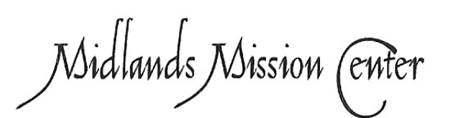
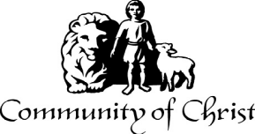

7615 Platte Purchase Dr, Suite 116 presidentteam@midlandsmc.org
Kansas City, MO 64118 www.midlandsmc.org

THIS IS THE WAY

Please join us for our annual fall conference!

Topeka Congregation – 5252 SW 19th St
We welcome individuals from across the mission center to gather for worship, fellowship, sharing, and planning alongside Mission Center President Rob Heverling and “soon to be” Senior President of Seventy Larry McGuire.
Sunday, November 1
Schedule
10:45 am Song Service
11:00 am Worship
12:00 pm Lunch
1:30 – 3:30 pm Business Meeting



JPAT Book Study
7pm Tuesdays 9/22, 10/6, 10/20, 11/10*

Join us as we explore Healing the Heart of Democracy by Parker Palmer. As the tension of living in a divided nation grows, finding common ground becomes more difficult each day. Palmer uses our hearts as a guide to reconcile and restore our democracy of freedom and responsibility. Registration is at bit.ly/JPAT-BS26. *Please note date change in November to avoid election day.

International Peace Forum

Seeds of Peace: Environmental Justice and Action

October 16 – 18

The event builds on the tradition of the International Peace Colloquy, offering worship, learning, and community engagement. All are welcome! Registration is now open! cofchrist.org/peace-forum

Racial Justice Summit

12 – 5:30 pm Saturday, November 7

The event sponsored by KC Disciples Becoming Beloved Community features Rev. Dr. Hanna R. Broome. It will be held at Intersect KC in KCMO. Register at KCDisciples.org/racial-justice.

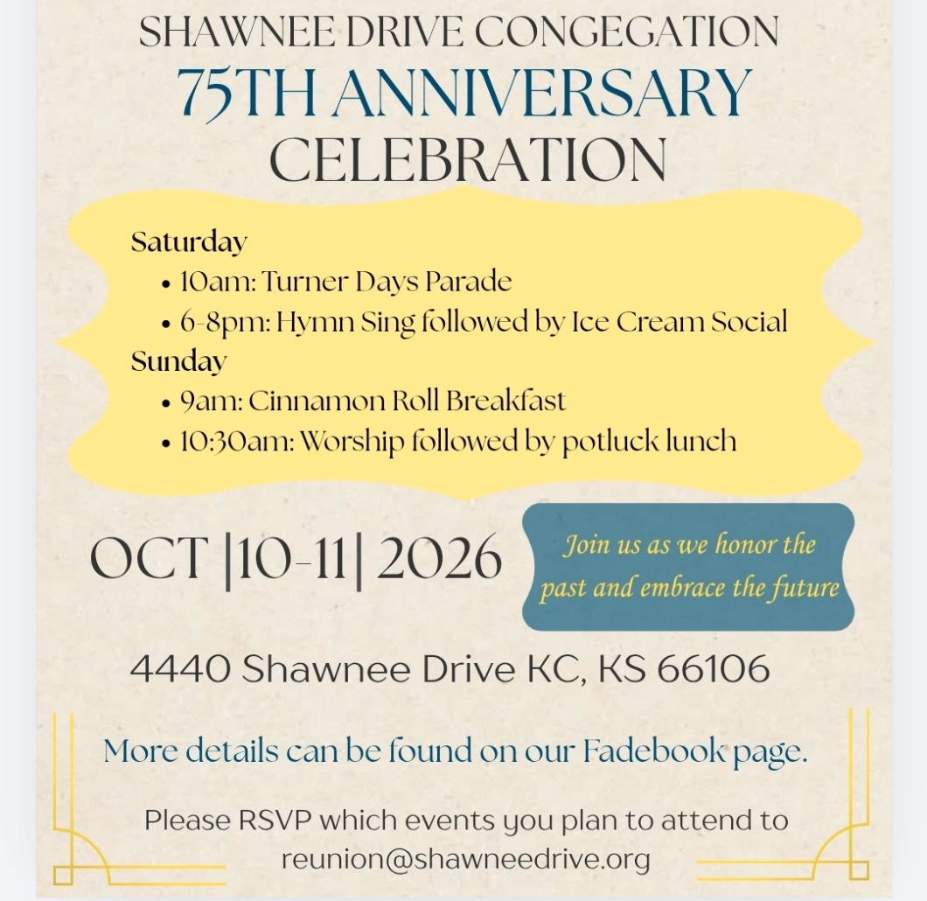

Youth & Young Adults
- 6pm Sat, Oct 10 @ Olathe – Young Adult Escape Room (bring a snack)
- 12pm Oct 24 @ The Highlands – Young adults make blankets to donate, watch Halloween movies, and eat pizza!
- Oct 24 @ Olathe – Youth Trunk or Treat, dinner, and activities
- 6pm Sundays YAM (Young Adult Ministry) online*
- 6pm Sunday, Oct 25 – Youth EMERGE online* gathering
- Bi-monthly online* Young Adult Coffee Talk

*For information, contact Humberto Tinsman htinsman@cofchrist.org

from the desk of
Rob Heverling

Recently, I have felt the weight of the legacies of all the congregations in the Midlands Mission Center. Over the past couple of weeks, I've had individual Zoom conversations with mission center pastors, and some financial officers have joined too. Every congregation has made a remarkable impact on its community, with countless examples of Spirit-led discipleship changing lives.
I learned a lot in the hour I spent listening to our congregations' leaders. I was struck by the unique Spiritual Gifts each congregation's members have displayed and deployed over the decades. And those Spiritual Gifts are still being humbly and powerfully wielded today.
It’s like I’ve been talking to a bunch of Jedi Knights who know the ways of the Force.
1st Corinthians 12: 4-7
4 Now there are varieties of gifts but the same Spirit, 5 and there are varieties of services but the same Lord, 6 and there are varieties of activities, but it is the same God who activates all of them in everyone. 7 To each is given the manifestation of the Spirit for the common good.
Here in the Midlands MC, I have been inspired by experienced and gifted people who have relentlessly worked to put Christ at the center of their lives and expressed Christlike love to so many people.
You all have reinforced what I believe… And that is, you are not even capable of wanting Jesus in the center of your life except by the Holy Spirit present in your life.
I’m enthralled by the matrix of Spiritual Gifts in the members of Community of Christ in our mission center. And the use of these gifts in the service of others, I feel, is more unique to our movement than other Faith traditions.
Our Spiritual Gifts are not necessarily inherent in us. We do not deserve these gifts. These are clusters of gifts bestowed on members of the Community of Christ to meet the needs of others.
And there are still many needs. This is why I have hope. This is why I believe there will be pockets of critical growth and impact for Midlands Mission Center as you all lean into your manifested gifts and walk the rugged road of servant ministry.
May the Force be with you.
Rob

