
Bethel Congregation
Midlands Mission Center
Welcoming the online community
Kansas City, KS
October 25, 2026 10:30AM CDT
How Deeply Do We Care?

Presiding Priest Sandra Billings
Announcements
Hymn of Gathering “All Creatures of Our God and King” CCS #98
Welcome
Call to Worship Psalm 90:1-2
1 Lord, you have been our dwelling place
in all generations.
²Before the mountains were brought forth
or ever you had formed the earth and the world,
from everlasting to everlasting you are God.
*Hymn of Centering “Spirit Fill Us” CCS #160
*Invocation Stan Troeh
*Response
Prayer for Peace Grace Troeh
Let there be peace on earth…
And let it begin with those who are willing to risk courageous love
Let there be peace on earth…
And let it begin with a community who is dedicated to the pursuit of justice and equality.
Let us walk with each other…
And let us shine your radiance into the darkness of the world.
Let peace begin with me…
And let this be the moment where we walk a new path towards healing and reconciliation.
Amen.

Message Seventy Kyle Joyce
Disciples’ Generous Response https://bit.ly/BethelGifts
God’s generosity is revealed in beautiful sunrises, waves on the shore, the face of a newborn child, music that touches our soul. But it’s also revealed in things as simple as the chairs we sit on or the clothes we wear. Discover what you’ve already received, where it came from and how you can use it for God’s purposes and vision for creation.
*Hymn of Renewal “Called by Christ to Love Each Other” CCS #577
*Pastoral Prayer Rob de Zwart
*Sending Forth Doctrine and Covenants 161:1b
Be faithful to the spirit of the Restoration, mindful that it is a spirit of adventure, openness, and searching. Walk proudly and with a quickened step. Be a joyful people. Laugh and play and sing, embodying the hope and freedom of the gospel.
*Congregation invited to stand

Bethel Community of Christ bethel.forthrightsystems.com
Pastor Rob de Zwart
Financial Officer Jeff Cady
Media Host David Troeh
CCS: Community of Christ Sings, ©2013, Herald Publishing House
NRSVue: New Revised Standard Version updated edition, ©2021 Nat’l Council of Churches of Christ. Used by permission. All rights reserved.
Permission to podcast/stream the music and text in this
service obtained from One License with license A-727171.
Announcements
- Sunday 10/25 9:45 am Lectionary Disc.— Matt 22:15-22
10:30 am How Deeply Do We Care?
Seventy Kyle Joyce speaking
- Tuesday 10/27 7:00 pm Together Tuesday (924 6108 0153)
- Sunday 11/1 Time change (another hour of sleep)
No Sunday School/lectionary discussion
10:45 am Song Service & Communion
in Topeka 1:30 pm Mission Center Conference
both available via zoom as well as in-person
- Our website, including weekly bulletin, web and zoom links: bethel.forthrightsystems.com
- Give through eTithing (https://www.cofchrist.org/give)
Optionally, search for Bethel, KS (or use link)

Recordings
All Creatures of Our God and King - CCS 98 - The Beyond the Walls Choir https://youtube.com/watch?v=ERE29Sgzvic
Spirit Fill Us - CCS 160 - The Beyond the Walls Choir https://youtube.com/watch?v=PVN5i2O4gcc
Called by Christ to Love Each Other - CCS 577 - The Beyond the Walls Choir https://youtube.com/watch?v=79UWmgYlsfw

Lectionary
3-year cycle engaging significant portions of our Scripture.
This Week Oct 25 How Deeply Do We Care?
1 Thessalonians 2:1-8 Deuteronomy 34:1-12
Psalm 90:1-6, 13-17 Matthew 22:34-46
Next Week Nov 1 All Saints’ Day

Psalm 34:1-10 Matthew 5:1-12
1 John 3:1-3 Revelation 7:9-17

Online Ministry & Priesthood Classes
Center for Innovation in Ministry and Mission (CIMM)

To enroll or for more information on these classes and the certificate programs, visit graceland.edu/CIMM. Cost is $25 unless noted.

October 19 – December 13

- Introduction to Scripture – David Lloyd
- Ministry of Deacon – David Lloyd
- CYW Core
- CIMM Missional Leadership – Larry McGuire
- CIMM Discernment as Process: Preparing the Community and Entering the Process

CIMM Sessions
CIMM Sessions are short seminars on topics of theology, culture, and Community of Christ Identity, Mission, Message, Beliefs and practices. Broadcast live and free on Zoom at 7:00pm most Wednesdays.
Register at graceland.edu/cimmsessions.

- Oct 7 – Year B and Advent Materials — Tyler Marz
- Oct 14 – Israel/Palestine Pt 1 – What are the causes of the conflict? — Andrew Bolton with Steve Kellogg, Destiny Magnet, Steve Glazer
- Oct 21 – “It’s Never as Simple as We Think” — Brittany Mangelson
- Oct 28 – WCR 1324, Resolution on Baptism and Membership — President Stassi Cramm


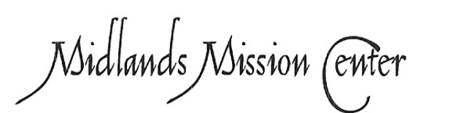
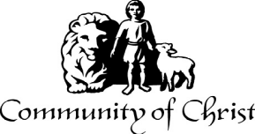

7615 Platte Purchase Dr, Suite 116 presidentteam@midlandsmc.org
Kansas City, MO 64118 www.midlandsmc.org

THIS IS THE WAY

Please join us for our annual fall conference!

Topeka Congregation – 5252 SW 19th St
We welcome individuals from across the mission center to gather for worship, fellowship, sharing, and planning alongside Mission Center President Rob Heverling and “soon to be” Senior President of Seventy Larry McGuire.
Sunday, November 1
Schedule
10:45 am Song Service
11:00 am Worship
12:00 pm Lunch
1:30 – 3:30 pm Business Meeting



JPAT Book Study
7pm Tuesdays 9/22, 10/6, 10/20, 11/10*

Join us as we explore Healing the Heart of Democracy by Parker Palmer. As the tension of living in a divided nation grows, finding common ground becomes more difficult each day. Palmer uses our hearts as a guide to reconcile and restore our democracy of freedom and responsibility. Registration is at bit.ly/JPAT-BS26. *Please note date change in November to avoid election day.

International Peace Forum

Seeds of Peace: Environmental Justice and Action

October 16 – 18

The event builds on the tradition of the International Peace Colloquy, offering worship, learning, and community engagement. All are welcome! Registration is now open! cofchrist.org/peace-forum

Racial Justice Summit

12 – 5:30 pm Saturday, November 7

The event sponsored by KC Disciples Becoming Beloved Community features Rev. Dr. Hanna R. Broome. It will be held at Intersect KC in KCMO. Register at KCDisciples.org/racial-justice.

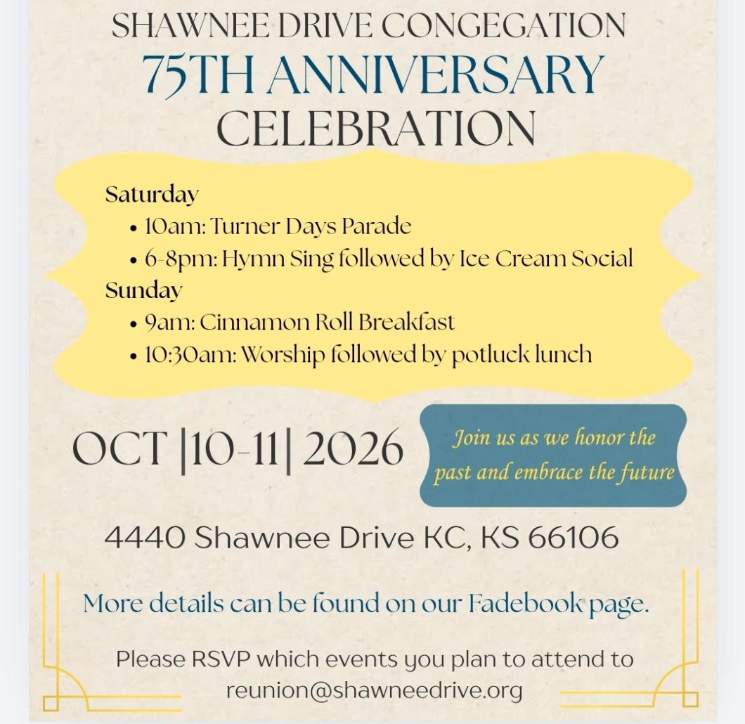

Youth & Young Adults
- 6pm Sat, Oct 10 @ Olathe – Young Adult Escape Room (bring a snack)
- 12pm Oct 24 @ The Highlands – Young adults make blankets to donate, watch Halloween movies, and eat pizza!
- Oct 24 @ Olathe – Youth Trunk or Treat, dinner, and activities
- 6pm Sundays YAM (Young Adult Ministry) online*
- 6pm Sunday, Oct 25 – Youth EMERGE online* gathering
- Bi-monthly online* Young Adult Coffee Talk

*For information, contact Humberto Tinsman htinsman@cofchrist.org

from the desk of
Rob Heverling

Recently, I have felt the weight of the legacies of all the congregations in the Midlands Mission Center. Over the past couple of weeks, I've had individual Zoom conversations with mission center pastors, and some financial officers have joined too. Every congregation has made a remarkable impact on its community, with countless examples of Spirit-led discipleship changing lives.
I learned a lot in the hour I spent listening to our congregations' leaders. I was struck by the unique Spiritual Gifts each congregation's members have displayed and deployed over the decades. And those Spiritual Gifts are still being humbly and powerfully wielded today.
It’s like I’ve been talking to a bunch of Jedi Knights who know the ways of the Force.
1st Corinthians 12: 4-7
4 Now there are varieties of gifts but the same Spirit, 5 and there are varieties of services but the same Lord, 6 and there are varieties of activities, but it is the same God who activates all of them in everyone. 7 To each is given the manifestation of the Spirit for the common good.
Here in the Midlands MC, I have been inspired by experienced and gifted people who have relentlessly worked to put Christ at the center of their lives and expressed Christlike love to so many people.
You all have reinforced what I believe… And that is, you are not even capable of wanting Jesus in the center of your life except by the Holy Spirit present in your life.
I’m enthralled by the matrix of Spiritual Gifts in the members of Community of Christ in our mission center. And the use of these gifts in the service of others, I feel, is more unique to our movement than other Faith traditions.
Our Spiritual Gifts are not necessarily inherent in us. We do not deserve these gifts. These are clusters of gifts bestowed on members of the Community of Christ to meet the needs of others.
And there are still many needs. This is why I have hope. This is why I believe there will be pockets of critical growth and impact for Midlands Mission Center as you all lean into your manifested gifts and walk the rugged road of servant ministry.
May the Force be with you.
Rob

